# **Chapter 1: Introduction**

## **Introduction**

Travel By Bus is a web-based application where people can book ticket for bus seats for travel easily with less effort and time. This system is built for managing and computerizing the traditional database, ticket booking and travel made. It records and maintains all the customer details, bus details and booking (reservation) details. It also facilitates the online payment system.

## **Background and Problem Statement**

Many website and applications like BusSewa.com, PNBBS, travelnepalbus.com, etc. especially for online ticket booking are available. These websites provide such facilities in Nepal but most of the customers are still unfamiliar with them. There is also popular app called redBus which provide online ticket booking services but it is not available in Nepal. Basically, I got the concept of this project from redBus.

At the current situation, the system used in the bus ticket counter of Nepal is an internal system which is manually. All the customer details, bus details and booking details are recorded in register by the staffs. These records cannot be well-maintained manually and there may be difficulty while searching for the required past records. So, it takes more effort and takes more time in order to get required details. The main problem with the current system is customers have to go to the ticket counter and ask for the tickets which is very time-consuming. Sometimes, they have to queue up for long time and have to pay cash while buying tickets as they do not have any other options like online payment. So, it is very difficult for the customers as well as it requires more human resources to manage the current system.

## **Overview of project**

## Travel By Bus is web-based application built for providing online bus ticket booking. This project is built to solve the problem of waiting in queue for booking the bus seat in front of ticket counter. It will save time, cost and effort. It also facilitates online payment. This system is developed in C# language using SQL server.

The main features of Bus ticket booking system are as follows:

* Online booking of ticket
* Online payment system for ticket
* Change of booked ticket system

## **Aims and Objectives**

The main aims of this project can be listed as below:

* To design the web-based application for booking the bus tickets.
* To design system which is user-friendly, time and effort saving.

There are so many objectives of the project in order to achieve its aims. Some of the main objectives to be fulfilled are as follows:

* Observation techniques is performed during analysis phase to get better view of what people want.
* Scheduling is done in order to finish project in time.
* To make it user-friendly, good and simple GUI is designed.
* Testing is performed to find out bugs in the system.
* Documentation of the project is done for the future reference.

# **Chapter 2: Analysis**

# **2.1 Introduction to Analysis**

Analysis is the second phase of the SDLC. This is performed after the planning phase. This phase is where the actual project lifecycle begins. This phase acts as the bridge between Planning and Design. After completing the planning phase, analysis phase begins and this phase is driven according to the plan. In this phase, we break down the deliverables in Project into the more detailed business requirements. The Analysis Phase is also the part of the project where we will identify the overall direction that the project will take through the creation of the project strategy documents. In this phase, we will study and determine the system requirements.  This helps to determine and understand what the customer wants from the project. This process consists of a group of repeatable processes that utilize certain techniques to capture, document, communicate, and manage requirements. This will be the main focus point of this phase.

Our objectives in the analysis phases can be listed as below:

* To determine and document how the current system works.
* To determine how the system can perform better.
* To develop a logical or business model of the new system/project.
* To make recommendations for improvement.

The three major steps to achieve the above objectives are as follows:

* Determine the system requirements
* Analyze the system requirements
* Evaluate the alternative solutions

At last, an optional document is created that helps transition from the Analysis Phase to the more technical and detailed Design Phase. This document, also known as Conceptual System Design, provides client feedback into many of the ways that the final solution will be implemented. This feedback includes much of the look-and-feel of the final solution.

# **2.2 Methodology**

Among the different methodologies like Hard approach, Soft approach, combine approach, People-oriented, process-oriented, etc. I have chosen Object-oriented methodology for analysis phase of this project.

In this methodology, the system requirements are determined, the classes are identified and the relationships among classes are identified. Object-oriented methodologies do not focus solely on the processes or data of a system but view a system as a collection of interacting ***objects*** that work together to complete tasks.

The three analysis techniques that are used in conjunction with each other for object-oriented analysis are object modelling, dynamic modelling, and functional modelling.

* **Object Modelling**

Object Modelling shows the object, classes, their relationships and attributes and operations as a *Class Diagram,* which represents the static structure of the system. The class diagram for this project is shown in design part.

* **Dynamic Modelling**

Dynamic modelling shows the behaviour of the system over time and the flow of control and events in *Event-Trace Diagrams* and *State Transition Diagrams (State Charts).* These diagrams will be shown in the design part of this project.

* **Functional Modelling**

Functional modelling is the final component of object-oriented analysis. It shows the internal processes independently from how these processes are performed with the help of Data Flow Diagram (DFD). I have created DFD diagram for this project as below:

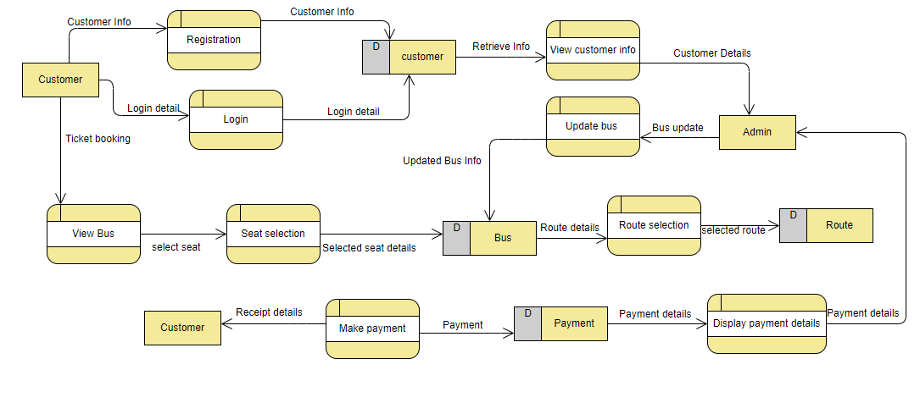

**Figure 1: Data Flow diagram**

# **2.3 Feasibility Study**

First of all, feasibility study refers to the analysis and evaluation of a proposed project to determine if it is technically possible, is possible within the estimated cost/budget, and will be profitable. It examines the practicability of any proposed projects or ideas. The main purpose of the feasibility study is to determine the project will continue or not.

The importance of the feasibility study can be shown as below:

* Shows how realistic your proposed project is.
* Helps to define goals.
* Determine the scope.
* Helps in plan development.
* Helps in plan execution.

# **2.4 Requirement Analysis**

## **2.4.1 Functional Requirement**

Functional requirements can be defined as the features and function of the system. It describes what a product must have. Product/system will be useless without functional requirements.

|  |  |  |  |  |
| --- | --- | --- | --- | --- |
| **ID** | **Title** | **Description** | **Rational** | **Dependencies** |
| F1 | Database connection | Database connection means allowing system to interact with database. | To perform CRUD function | N/A |
| F2 | User Registration | Registration means registering the new user to the system to access the system. | To create new user | F1 |
| F3 | User login | Login is the entering of identifier info into system for accessing the system. | To access the system | F2 |
| F4 | Logout | Logout means to end the access to the system voluntarily. | To avoid security issues | F3 |
| F5 | Payment |  | To do payment for booking | F3 |
| F6 | Authentication | Authentication means identifying individual who is logging in. | To avoid unauthorized access to the system | F1 |
| F7 | Add buses | Only admin can add new buses in the system | To add new buses | F3 |
| F8 | Remove buses | Only admin can remove buses from the system | To delete buses | F3 |
| F9 | Update bus details | Only admin can update the bus details | To update bus details | F3 |
| F10 | Add route | Only admin can add route in the system | To add route | F3 |
| F11 | Remove routes | Only admin can remove the route from the system | To delete routes | F3 |
| F12 | Update route details | Only admin can update route details in the system | To update route details | F3 |
| F13 | Viewing bus details | Both admin and general users can view the bus details | To view the bus details | F3 |
| F14 | Searching routes | This function helps users to get their desired routes. | To search routes | F3 |
| F15 | Seat viewing | User can view whether seat is booked or available | To view seat details | F3 |
| F16 | Seat Booking | User can select available seats and book them. | To book seat | F3 |
| F17 | Cancel reservation (only available for admin) | Only admin can cancel the reservation as per user request | To cancel the reservation | F3 |

**Table 1: Functional Requirements**

## **2.4.2 Non-functional Requirement**

Non-functional requirements can be defines as the general characteristics of the system. They are also known as 'Quality attributes'. Product/system can work without non-functional requirement but if it is added then it helps to enhance the productivity, efficiency and functionality of the product.

|  |  |  |  |  |
| --- | --- | --- | --- | --- |
| **ID** | **Title** | **Description** | **Rational** | **Dependencies** |
| N1 | Performance | System should have quick response time. | To make user more satisfied | N/A |
| N2 | Scalability | System should function well as user increases. | To handle the large number of the user effectively | N/A |
| N3 | Recoverability | System should be able to recover from a crash | To avoid effects of the possible threats of the system | N/A |
| N4 | Availability | System should be available anytime. | To provide better facility to the users | N/A |
| N5 | Reliability | System is expected to provide reliable data to user | To build trust within the users and good relation with them | N/A |
| N6 | Maintainability | System should be designed in such way that it can be maintained on a regular basis. | To ensure the condition of the system and improve the system | N/A |
| N7 | Security | System must have data security and have proper access control | To maintain data security and avoid unauthorized access | F2, F3 |
| N8 | Usability | System should be easy to learn and operate. | To make more user friendly | N/A |
| N9 | Interoperability | System should be designed in such way that it can work in integration with different systems. | To enhance the functionality of the system | N/A |
| N10 | Serviceability | Technical supports should be provided to install, configure and monitor system and other related facilities should be provided. | To make easy for the user to cope up with the system | N/A |
| N11 | Manageability | System should be easy to manage. | To ensure healthy monitoring, logging and alerting | N/A |
| N12 | Legal | System must be legal in the country. | To work in the market legally | N/A |
| N13 | Capacity | System must store data effectively and must anticipate the time remaining until all available storage is filled up. | To ensure that multiple users can use the system at the time | N/A |

**Table 2: Non-Functional Requirements**

## **2.4.3 MoSCoW Prioritization**

MoSCow prioritization is the popular prioritizing technique for understanding and managing requirements. It is also known as MoSCoW method or MoSCoW analysis.

This technique divides requirements into 4 categories:

* **Must-have**

This category includes those requirements has to be included in the product. They represents non-negotiable needs of the project.

* **Should-have**

Requirements under this category are important to the project but not vital as must-have requirements. The project still works without them but the project will be more effective if they are added.

* **Could-have**

These requirements are not necessary to the core function of the project. In other word, they are nice to have.

* **Would-have**

The requirements under this category are not included in a specific release but they are likely to be added in the future. They will get prioritized in the future.

|  |  |  |  |
| --- | --- | --- | --- |
| **ID** | **Title** | **MoSCoW** | **Remarks** |
| F1 | Database connection | Must have |  |
| F2 | User registration | Must have |  |
| F3 | User login | Must have |  |
| F4 | Logout | Must have |  |
| F5 | Payment | Must have |  |
| F6 | Authentication | Must have |  |
| F7 | Add buses | Must have |  |
| F8 | Remove buses | Must have |  |
| F9 | Update bus details | Must have |  |
| F10 | Add routes | Must have |  |
| F11 | Remove routes | Must have |  |
| F12 | Update route details | Must have |  |
| F13 | Viewing bus details | Must have |  |
| F14 | Searching routes | Must have |  |
| F15 | Seat viewing | Must have |  |
| F16 | Seat booking | Must have |  |
| F17 | Cancel Reservation | Must have |  |
| N1 | Performance | Should have |  |
| N2 | Scalability | Could have |  |
| N3 | Recoverability | Must have |  |
| N4 | Availability | Should have |  |
| N5 | Reliability | Should have |  |
| N6 | Maintainability | Should have |  |
| N7 | Security | Must have |  |
| N8 | Usability | Should have |  |
| N9 | Interoperability | Could have |  |
| N10 | Serviceability | Would have |  |
| N11 | Manageability | Would have |  |
| N12 | Legal | Must have |  |
| N13 | Capacity | Should have |  |

**Table 3: MoSCoW Prioritization**

## **2.4.4 SRS (System Requirements Specification)**

SRS is the description of the system to be developed. It describes the features and behavior of the system to be developed. It is also known as 'Software Requirement Specification'. The details in SRS may vary according to the methodology chosen. Generally, SRS includes functional requirements, non-functional requirements, technical requirements, constraints, assumptions and acceptance criteria.

The system being developed requires following system specification:

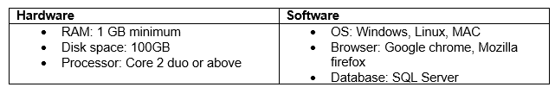

# **2.5 Use-case diagram**

Use case is the graphical representation of the interaction between users (actors) and the system. It shows what a user can do in the system. It summarizes the details of the users and their interaction with the system. The notations used in the use-case diagram are as follows:

* **Use cases:** It is horizontally shaped ovals that represent the different uses that a user might have.
* **Actors:** Stick figures that represent the people actually employing the use cases.
* **Associations:** A line between actors and use cases. In complex diagrams, it is important to know which actors are associated with which use cases.
* **System boundary:** It is shown as a box that sets a system scope to use cases. All use cases outside the box would be considered outside the scope of that system.

**The reasons behind using the use-case diagram are as follows:**

* Define the interaction between users and the system.
* Define the roles of the users in the system.
* Define and organize the functional requirements.
* Model the basic work flow in the system.

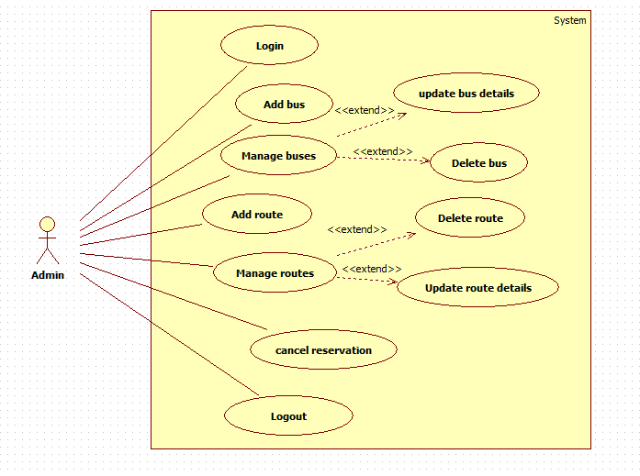

**Figure 2: Use case diagram-admin**

**Description:**

Actor: Admin

Admin is the super user of the system who can perform the following activities:

* Admin can login into the system.
* Admin can add buses in the system.
* Admin can manage the buses which includes update bus details and delete buses from the system.
* Admin can add routes in the system
* Admin can manage the routes which includes update route details and delete routes from the system.
* Admin can cancel the reservation on the request of the customer/passenger.
* Admin can logout from the system at his/her convenience.

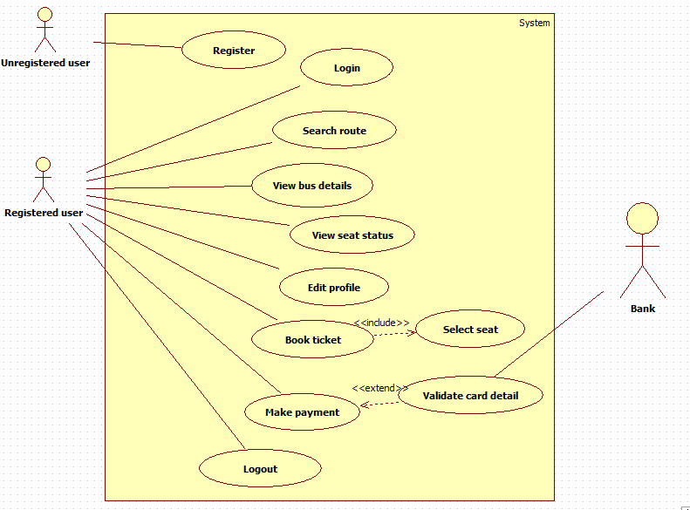

**Figure 3: Use case diagram-general user**

**Description:**

Actor: customer (general user)

Customer is the general user of the system who can perform the following actions in the system:

* Unregistered user can register themselves in the system.
* Registered user can login into the system.
* Customer can view bus details for booking.
* Customer can view the seat status that is booked or available.
* Customer can edit their profile.
* Customer can book the ticket.
* Customer can make the payment for the booking.
* Customer can logout from the system as per their wish.

# **2.6 NLA and Initial class diagram**

'Travel By Bus' is the online bus ticket booking system. This is a web-based application where people can book ticket for bus seats for travel easily with less effort and time. This system is built for managing and computerizing the traditional database, ticket booking and travel made. The main aim of this system is to automate the manual booking reducing the paper works. It records and maintains all the customer details, bus details and booking (reservation) details. It also facilitates the online payment system.

There are two types of users in the system: General User and Admin. If user is not registered, then he/she has to register first. He/she has to register with some data like email, name, password, phone, etc. After registration, General user can book the ticket, search the routes, view seat status that is available or booked, and view the bus details. On the other side, Admin can add and manage buses (update and delete function), add and manage routes (update and delete function), and cancel the reservation. General user cannot cancel the reservation as they have to inform the ticket counter to do so.

From the above scenario, NLA is performed and candidate classes, methods and attributes are found out by separating noun, verb and adjective respectively.

|  |  |  |
| --- | --- | --- |
| **Candidate Classes** | **Candidate Method** | **Candidate attribute** |
| seat, payment, users, route, bus | Book, register, search, view, add, delete, update, cancel | email, name, password, phone |

Class diagram is a type of static diagram that describes the structure of the system by showing the system's class, their attributes, operations and relationship between them.

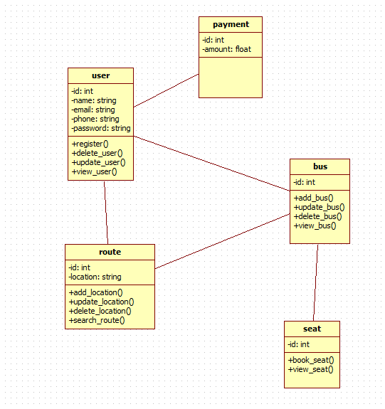

**Figure 4: Initial class-diagram**

# **Chapter 3: Design**

# **3.1 Introduction**

Design is the one of the most crucial phase in SDLC. Based on the user requirements and the analysis of the system, the system must be designed. The logical design made during the analysis phase starts to taking shape into physical design during this phase. Problems are identified during the previous phase and a detailed description of what is needed to solve that problems are produced this phase. This is the phase where we take decision about how the system will meet the requirements identified during analysis phase.

# **3.2 Structural Modelling**

## **3.2.1 Final class diagram**

Class diagram is UML structural diagram that shows the relationship between class(entities) of the system. It is static diagram that represents the static view of the system. Class diagram describes the class’s attributes, operations, and the system’s constraints. It is the backbone of the system.

**Notations:**

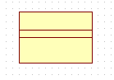

**Class**

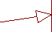

**Generalization**

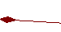

**Composition**

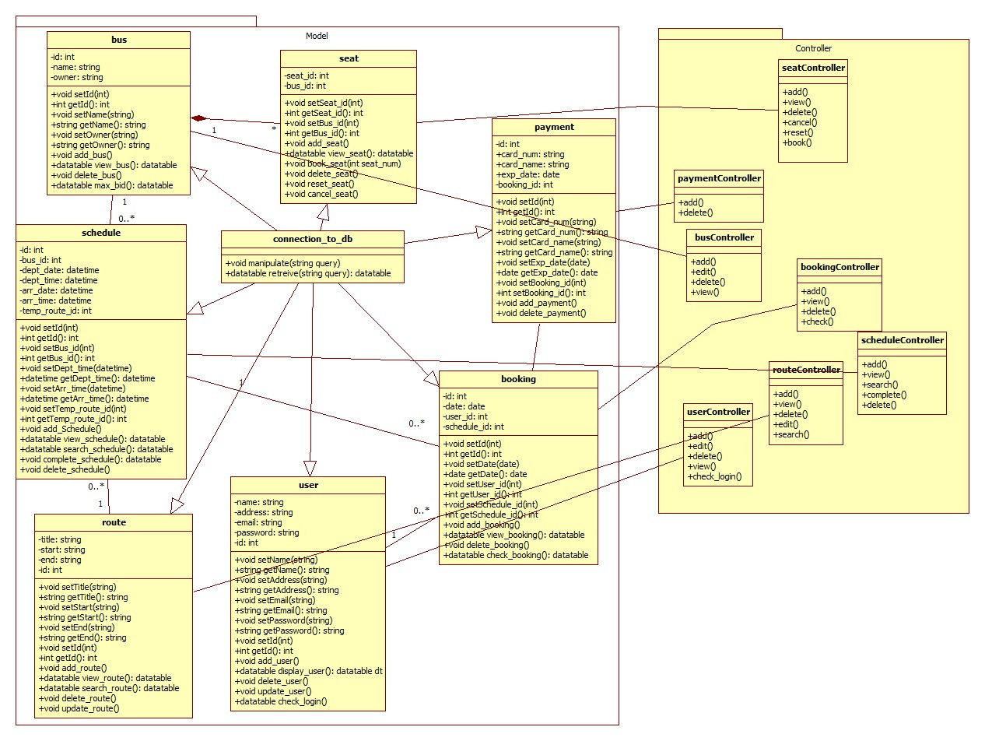

Fig: Class diagram

In the above figure, model along with respective controller are illustrated. Controller are being used to link between views and models. This diagram includes model, controller and view as MVC design pattern is being followed.

## **3.2.2 Flowchart**

Flowchart is UML diagram that represents the sequence of steps and decisions needed to perform a process. It communicates the steps in a process efficiently and effectively.

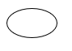**Notations:**

**Terminator**

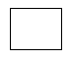

**Process**

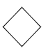

**Decision**

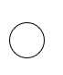

**Connector**

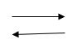

**Flow Lines**

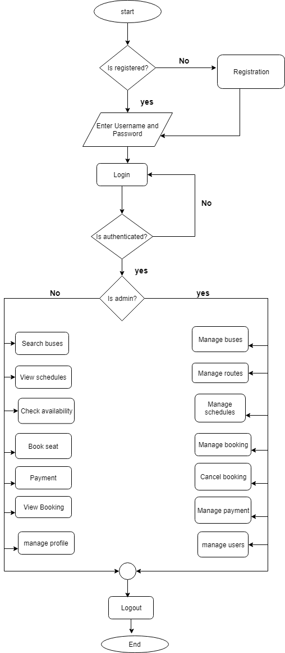

Fig: System flowchart

This figure shows the flowchart of the system. After the start of the flow, user is registered or not is confirmed. If not, registration is done. Then, user has to enter username and password and login process is carried. Is that user authenticated or not is checked. If user is authenticated, flow is carried on. Otherwise, user has to enter inputs again. After this, is user is admin or not is checked. If user is admin, admin related process can be done. If user is not admin, normal process can be done. After that, both flow lines are connected and logout process is performed. In this way, the flow ends here.

# **3.3 Behavioral Modelling**

## **3.3.1 Activity Diagram**

Activity diagram is flowchart to represent the flow from one activity to another activity. The activity can be represented as the operation of the system. It shows the workflow in the system. It shows the dynamic behavior of the system and also describe the sequence from one activity to the another.

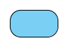**Notations:**

**Activity symbol**

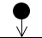

**Start symbol**

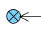

**Flow final symbol**

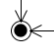

**End Symbol**

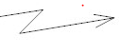**Interruption symbol**

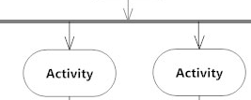

**Fork symbol**

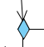

**Decision symbol**

**Fig:**

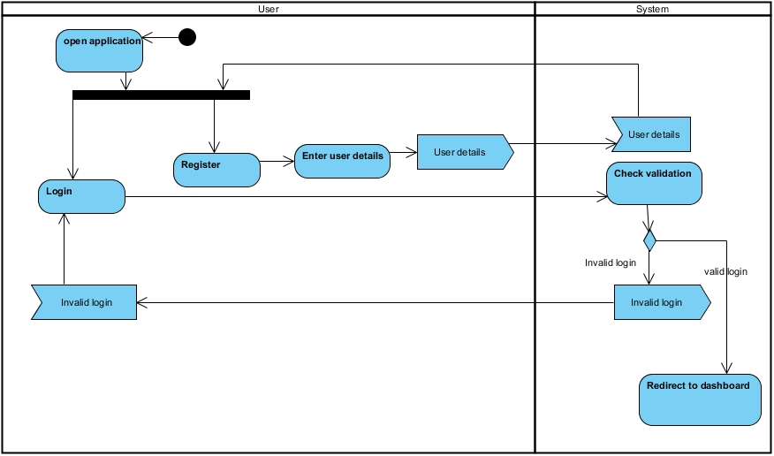

Fig: Login and register

This figure shows the activity diagram of login and register. User must register and then signed in to use the system. For registration, user send their details to the system and after this, user can login. While logging in, system validates the login details and redirect to dashboard if login is valid.

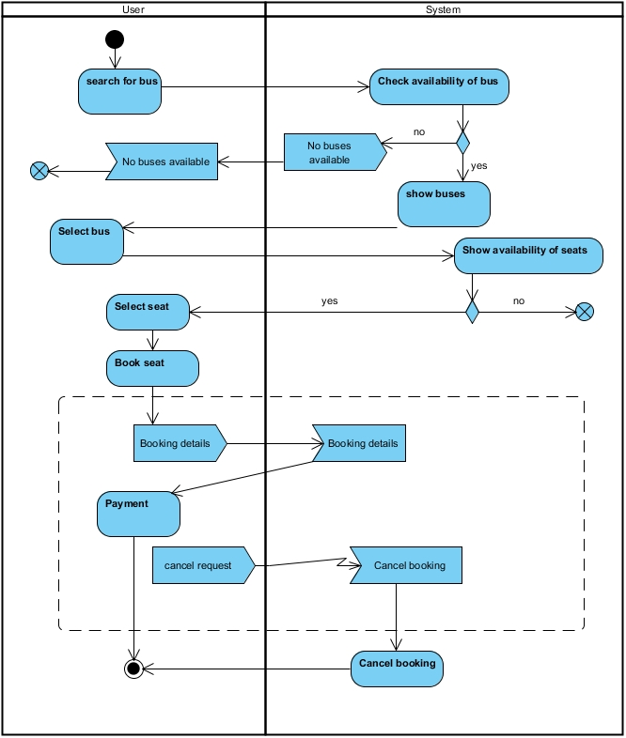

Fig: Main activity

This diagram shows the main activity of the system after login. User search for the bus and system check it. If it is available, system show it to the user. Otherwise, no buses are available message is sent. Then, user select the bus and select the available seats. After this, user book the seat and payment is done.

## **3.2.2 Sequence Diagram**

Sequence diagram is UML behavioral diagram that describe the interactions among class and object in term of an exchange of messages over time. It is also known as “Event diagram”. It shows how the system will behave in different scenarios and helps to validate the logic of complex operations and functions.

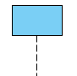**Notations:**

**Lifeline**

 **Send message**

 **Return message**

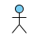 **User**

**Fig:**

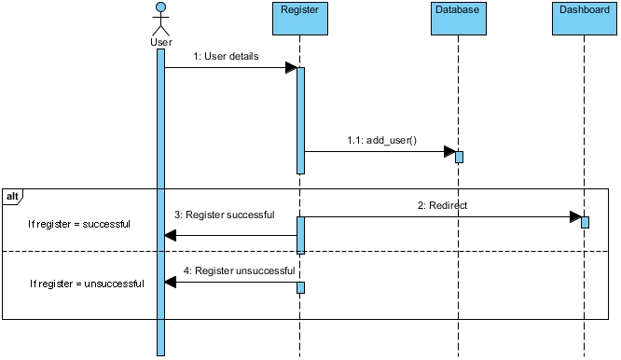

Fig: Registration

This figure shows the sequence diagram of registration. User sends user details to the system and the system sends it to the database. If registration is successful, successful message is displayed and redirected to the dashboard. Otherwise, unsuccessful message is sent.

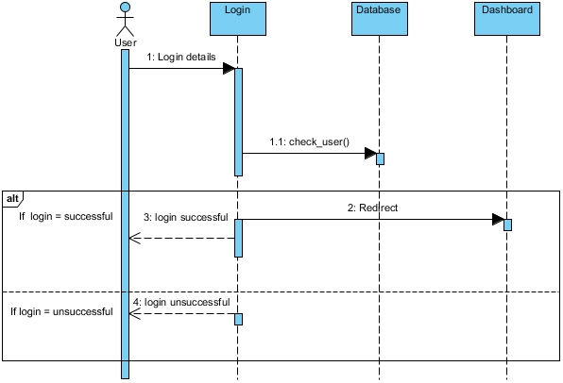

Fig: Login

This figure shows the sequence diagram of login. User sends login details to the system and the system validate it with the database. If login is successful, successful message is displayed and redirected to the dashboard. Otherwise, unsuccessful message is sent.

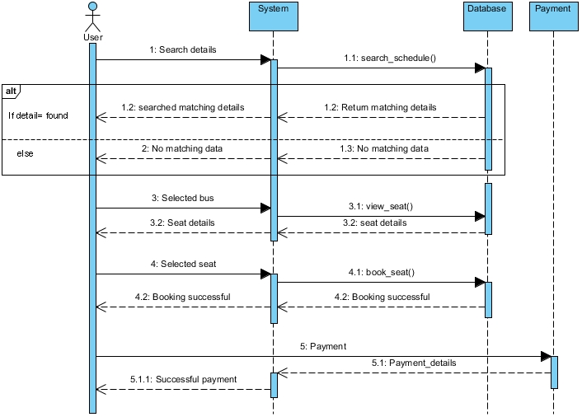

Fig: System Flow Sequence diagram

This figure shows the sequence after user logged in. User send search details to the system and system search it in database. If it is matched, then matching details are sent to the user. Otherwise, no matching data message is sent. User select the bus and system view the seat of the selected bus and show it to the user. Then, user selects the available seats and send it to the system for booking. After booking, system sent the successful message. Payment is done and payment details are sent to the user.

# **3.4 Database Modelling**

## **3.3.1 Data Dictionary**

Data dictionary is file that contains the database’s metadata. It is also known as “Data definition matrix” or “Metadata repository”. It provides the names, definitions and attributes about the data elements.

**User:**

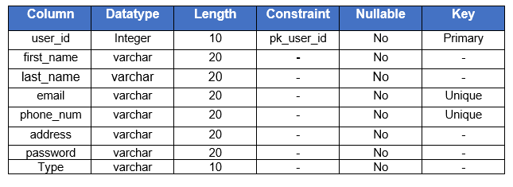

**Bus:**

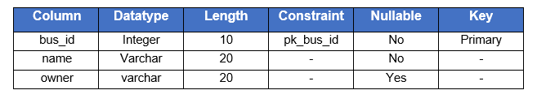

**Route:**

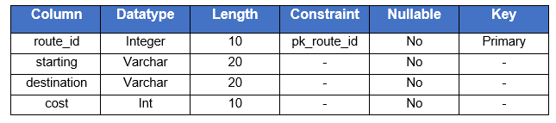

**Seat:**

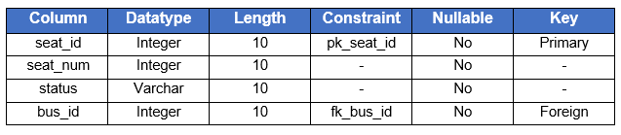

**Schedule:**

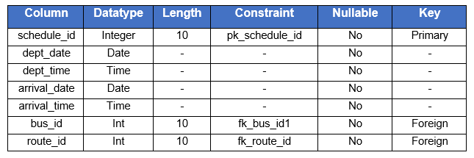

**Booking:**

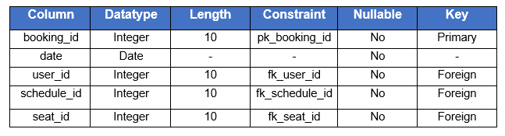

**Payment:**

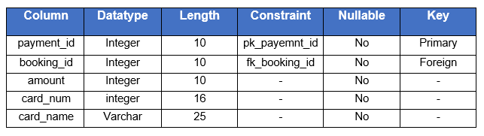

## **3.3.2 ER diagram**

ER diagram is a type of structural diagram in which the relationships of entities stored in the database are shown. It can be used as the foundation for relational database. It illustrates the logical structure of the database.

**Notations:**

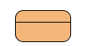

**Entity**

 **One to many relationship**

 **One to one relationship**

**Fig:**

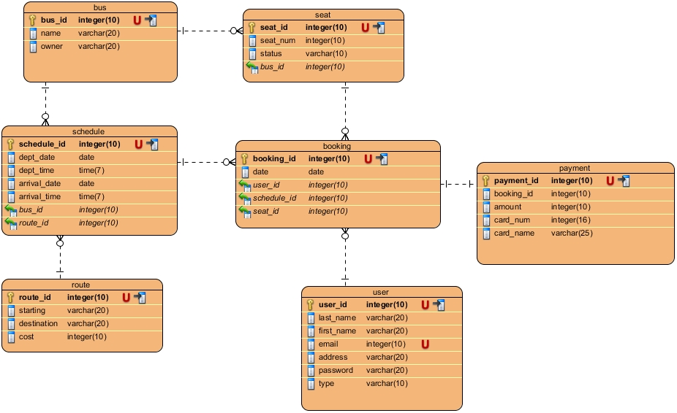

Fig: ER diagram

Above ER diagram is evolved from the data dictionary created above with the relationships that the entities have with each other.

# **3.5 Architectural Model**

As said in the proposal, I will use client-server architecture. In client-server architecture, I’m using three-tier architecture. Three-tier architecture is client-server architecture in which presentation, application processing and data management function are physically separated. It consists of three tiers:

1. **Presentation tier**

It contains UI part of the application. It is used for designing where data is presented to users and inputs are taken from them.

1. **Application tier**

This tier is also known as ‘middle tier’ or ‘logic tier’. All the business logic written like data validation, data insertion, etc. are done. It acts as the bridge between presentation tier and data tier.

1. **Data tier**

Actual work with database comes in this tier. It contains methods to connect with database in order to perform CRUD function.

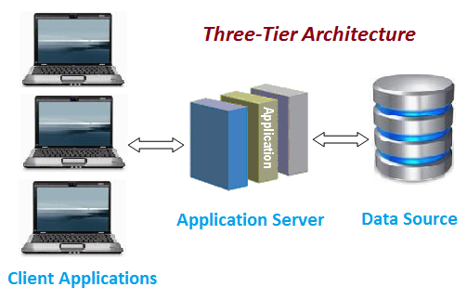

Fig: Three-tier architecture

The reasons behind using three-tier architecture for the project are as follows:

* More security
* Scalability
* High performance
* Improve data integrity
* Easy in maintenance and modification

# **3.6 Prototyping**

Prototyping refers to the creating the prototypes (model)of the system. It shows how the system will look like and how it will work. It facilitates in system implementation since feedback can be received from the users.

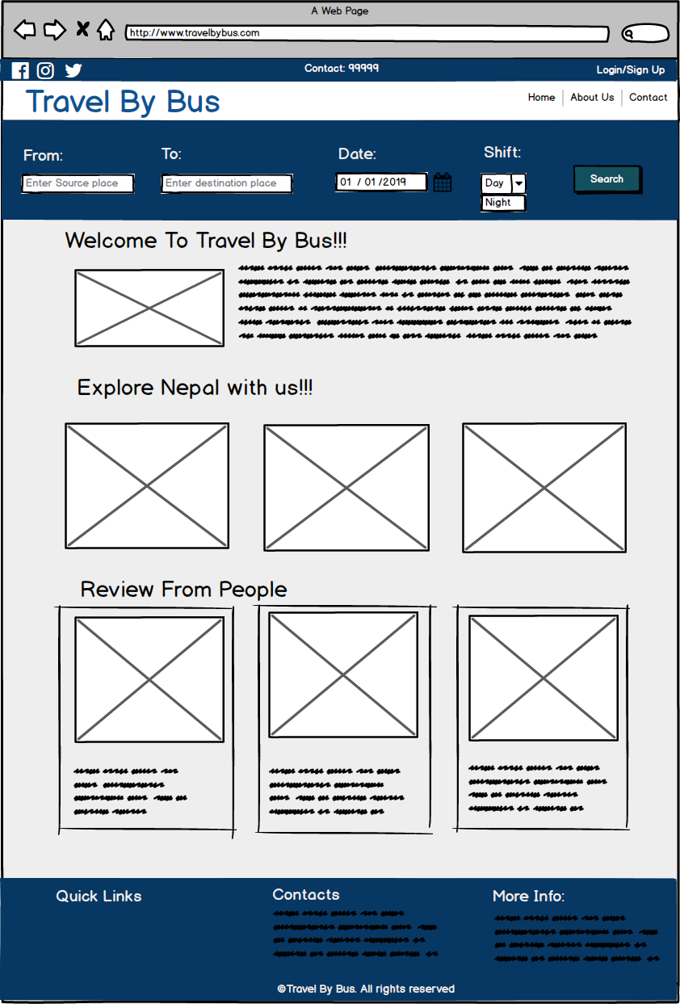

Fig: Homepage

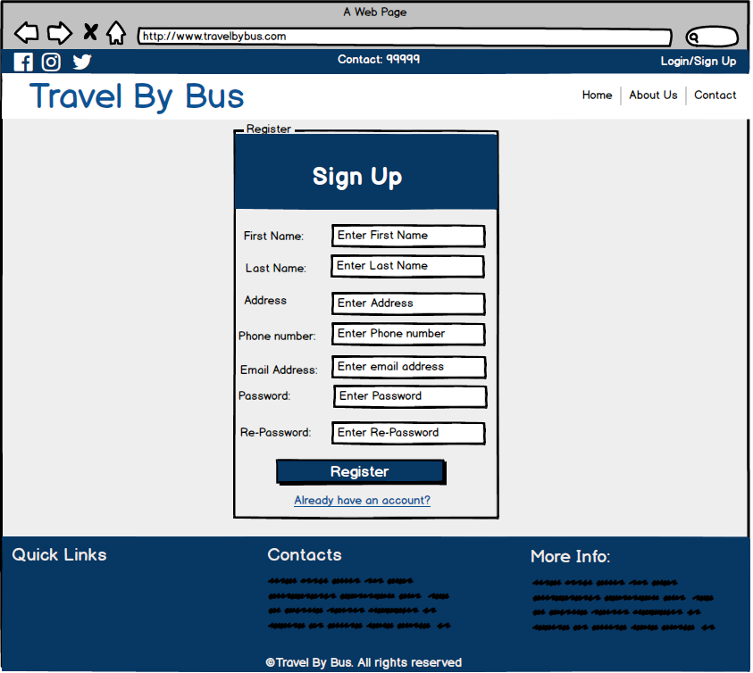

Fig: Register

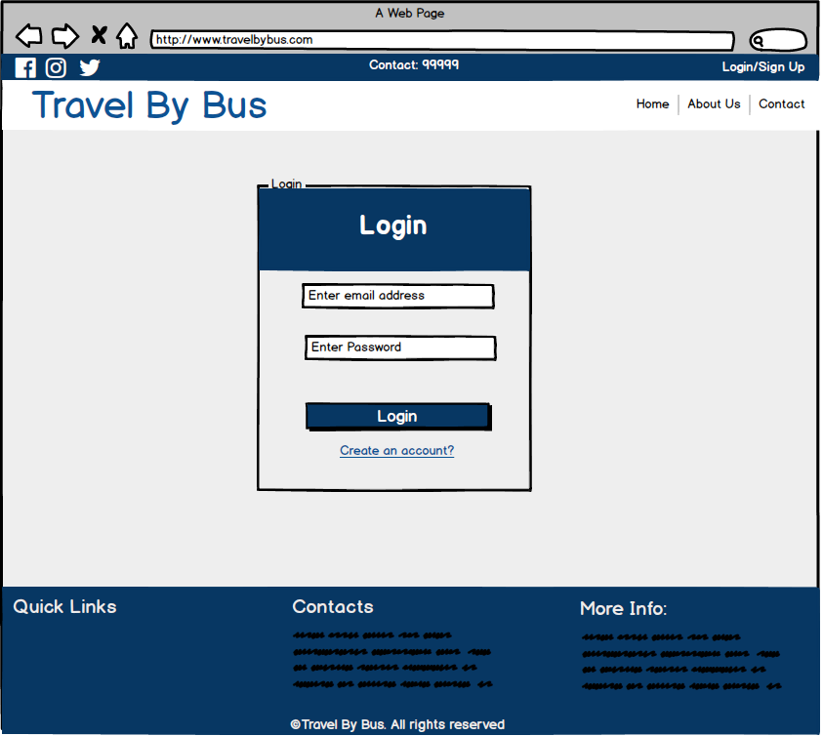

Fig: Login

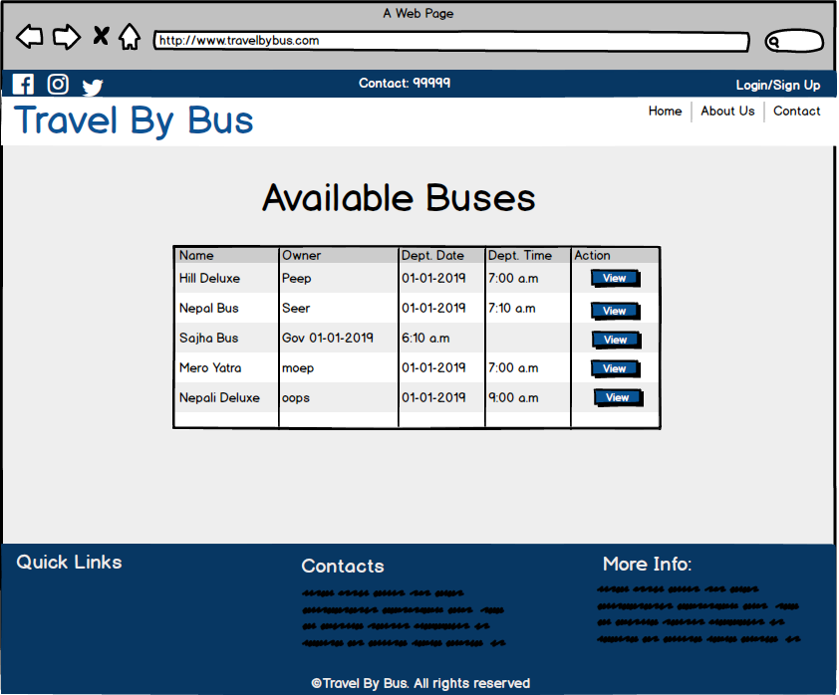

Fig: View Bus

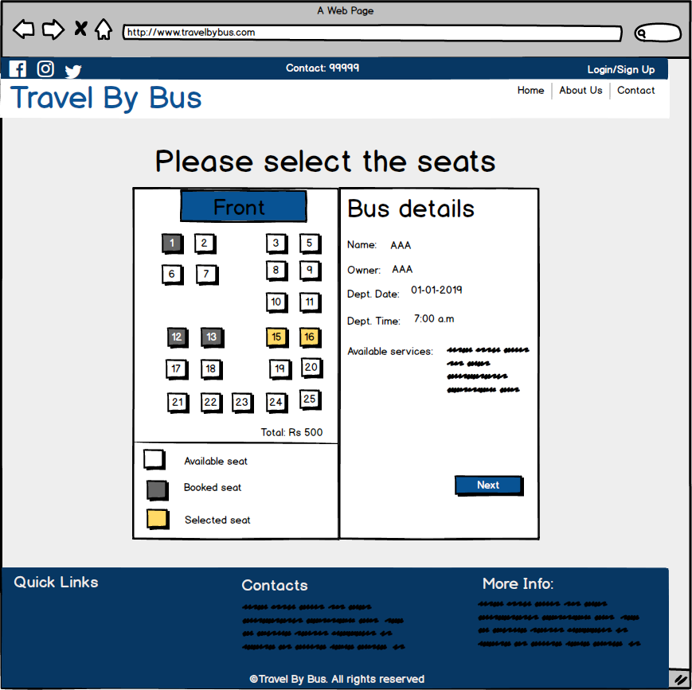

Fig: Seat Booking

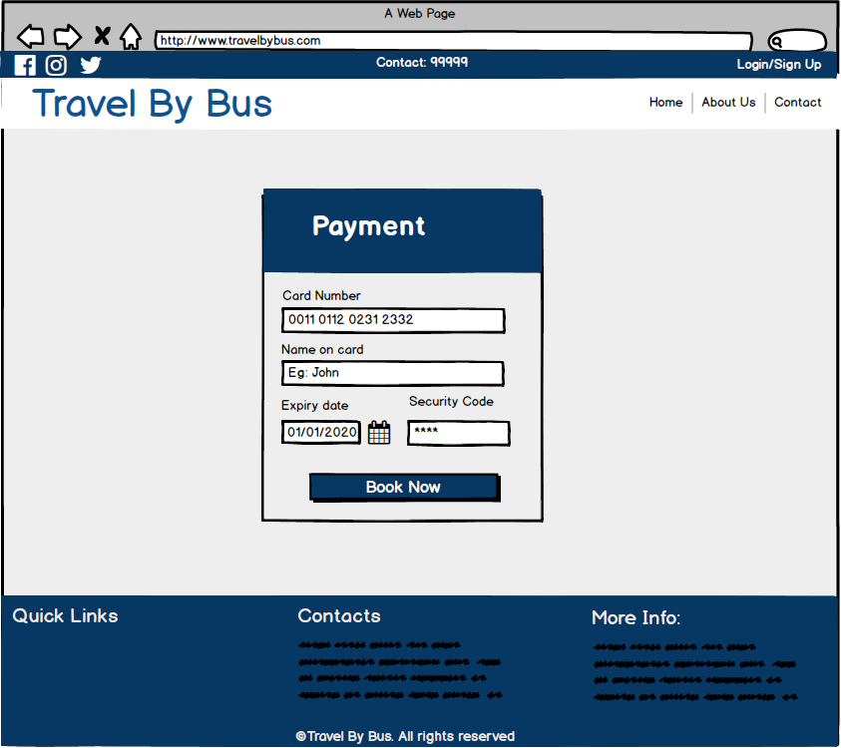

Fig: Payment

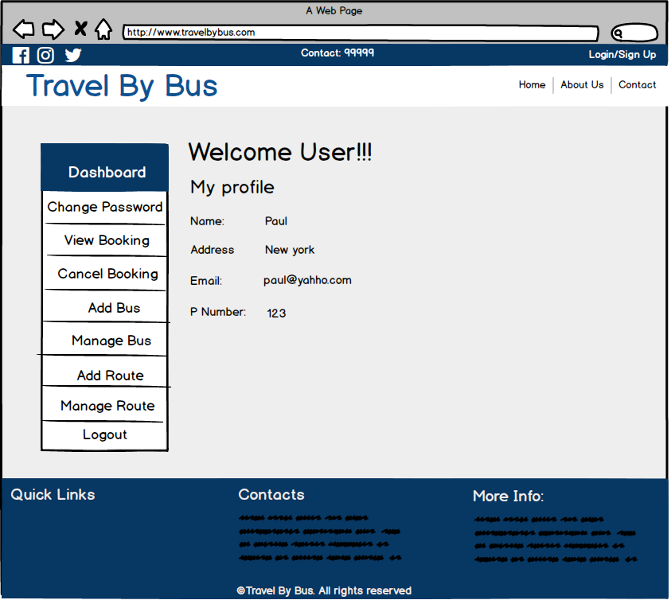

Fig: Admin Panel

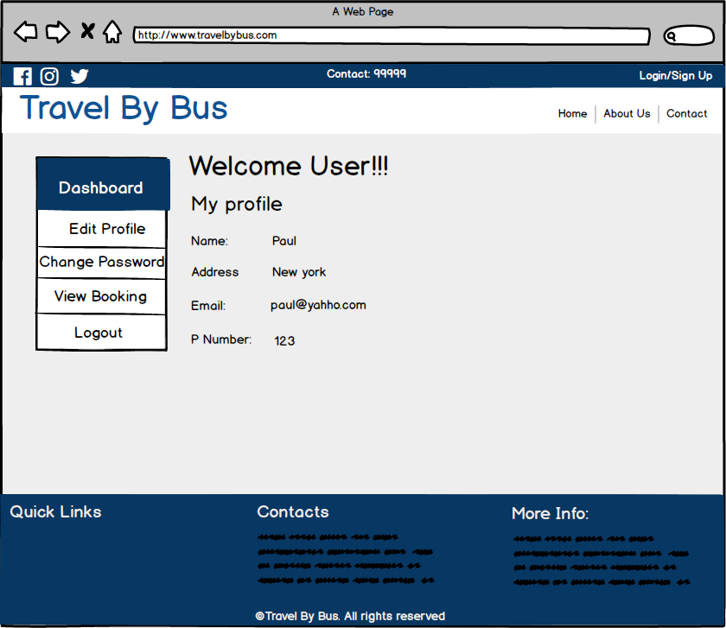

Fig: General user panel

# **Chapter 4: Coding**

# **4.1 Introduction**

After the design phase, coding/development phase is started. This is the third phase of SDLC. After taking the major decisions regarding the system during the design phase, it is developed as physical system/product in the coding phase. The main task of this phase is to convert the designing models into real products. The well-developed code in this phase can help to reduce the efforts required during testing and maintenance phases.

# **4.2 Programming Language**

For this project, I have chosen C# language for the coding/programming. C# is modern object-oriented programming language developed in 2000 by Anders Hejlsberg at Microsoft. It is designed for developing apps and games on the Microsoft platform. It requires the .NET framework on window to work.

# **4.3 Design pattern and framework**

I have used MVC design pattern. MVC is design pattern that separates an application into three main logical components: Model, View and Controller. This pattern helps to achieve separation of concern.

I have used ASP. NET MVC framework. ASP. NET MVC is an open-source server-side web application framework designed for web development which implements MVC design pattern. It is part of .NET framework for building, deploying and running web applications. I have also used Entity Framework. Entity framework is O/RM(Object-Relational Mapping) which comes as the part of the .NET framework. It automates all these database related activities for the application.

# **4.4 Tools used**

OS used: Windows 10

Tools used for coding:

* **Visual studio 2017**
* **Google chrome**

# **4.5 Codes**

## **Models:**

### **Booking**

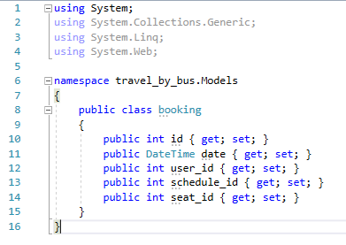

### **Booking Per User**

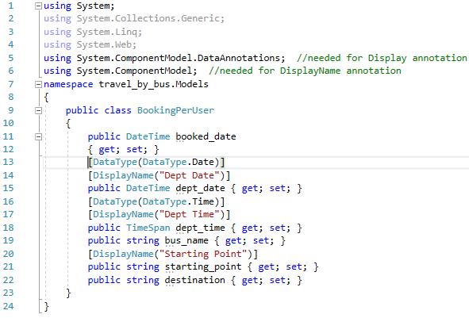

### **Bus**

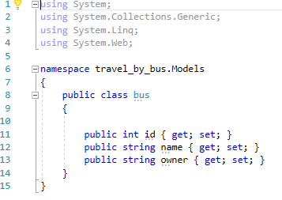

### **Bus Per Schedule**

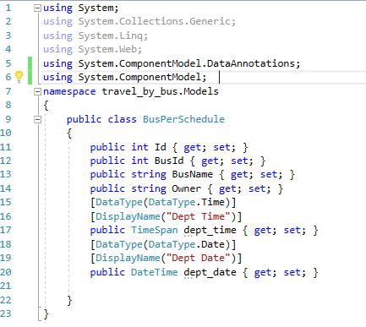

### **Payment**

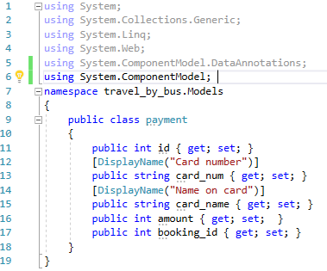

### **Route**

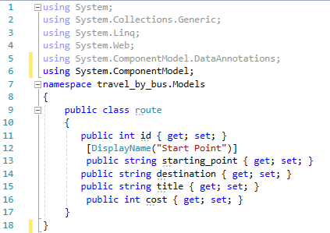

**Schedule**

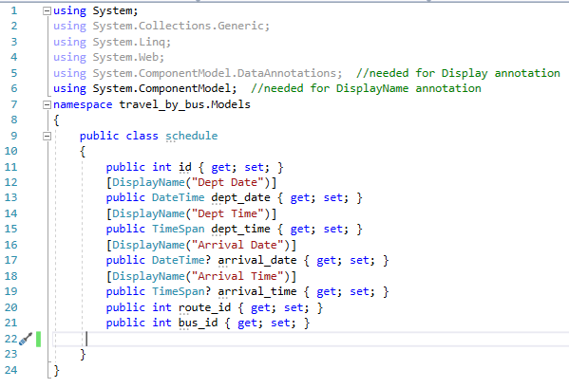

### **Seat**

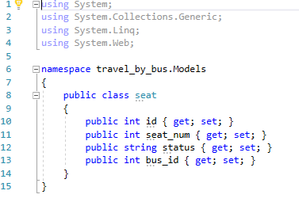

### **User**

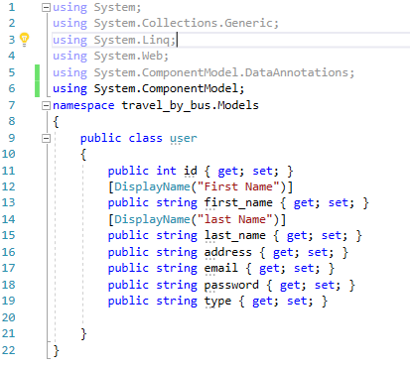

### **View Schedule**

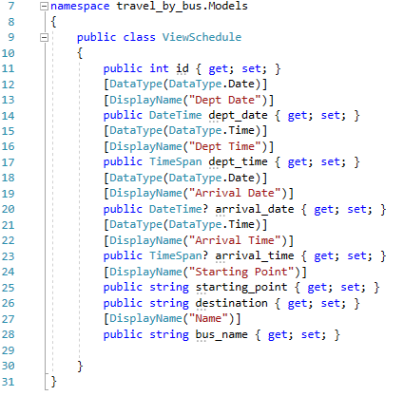

### **Travel By Bus Context**

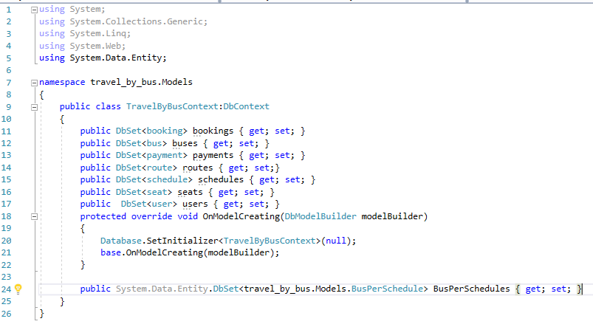

## **Controller**

### **buses**

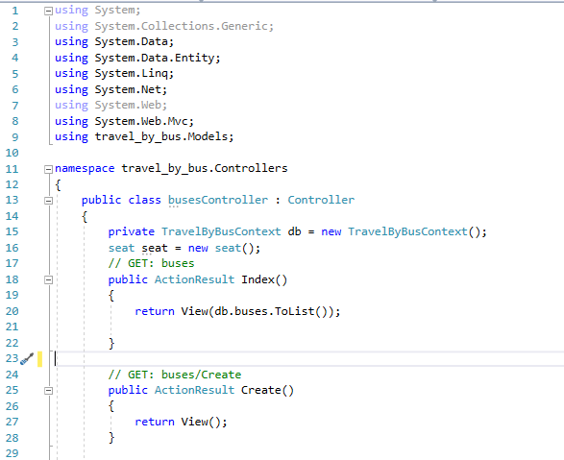

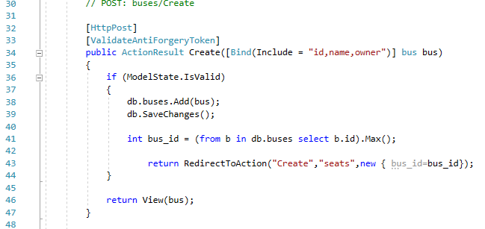

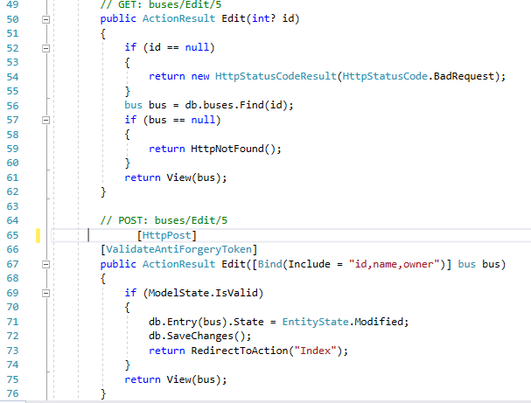

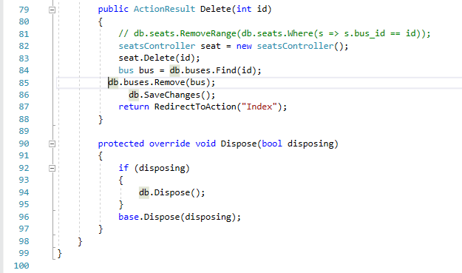

### **bookings**

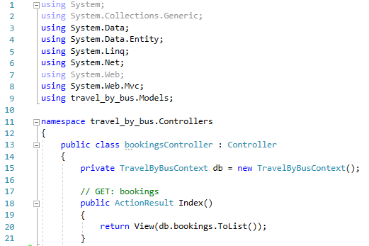

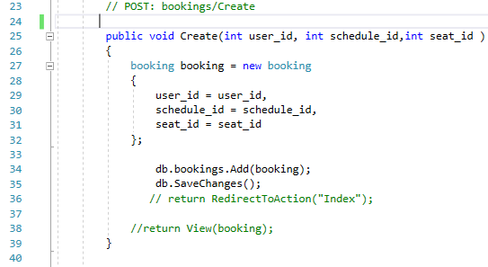

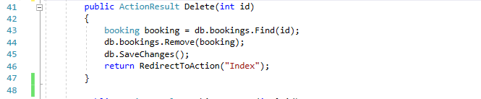

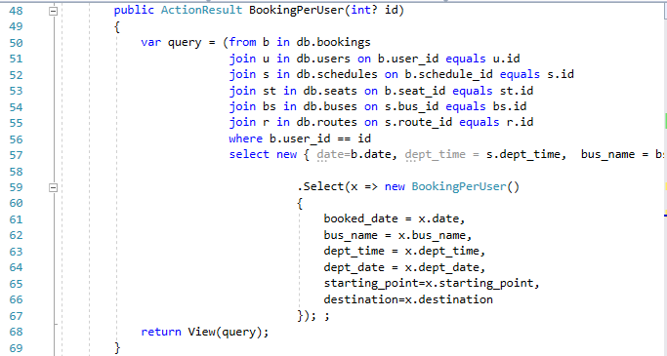

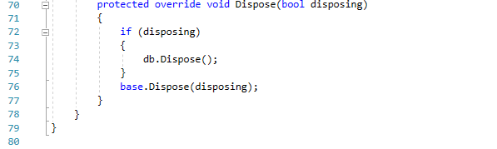

### **Home**

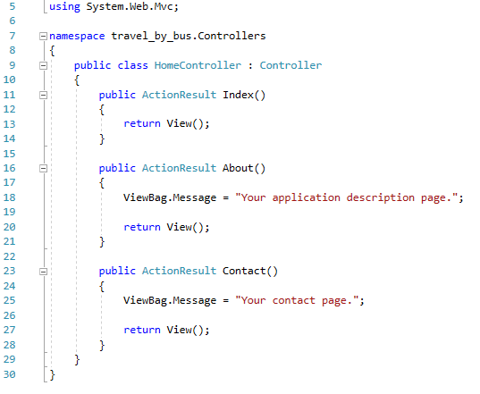

### **Payments**

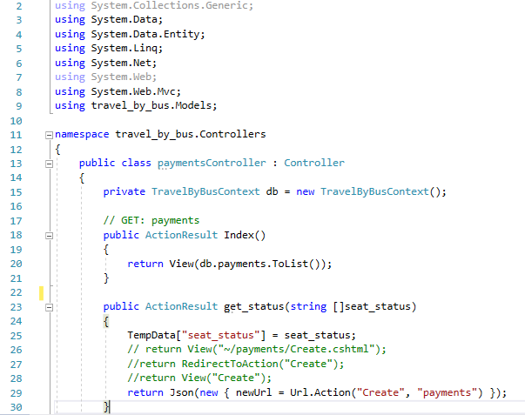

### **routes**

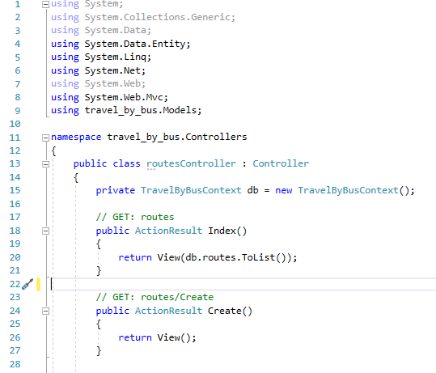

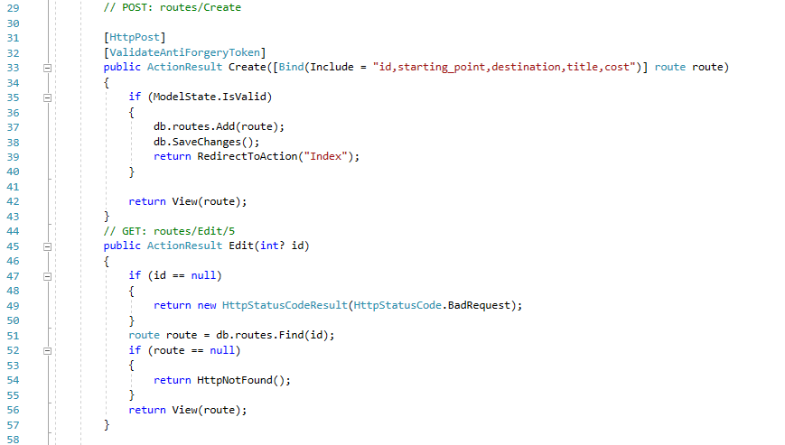

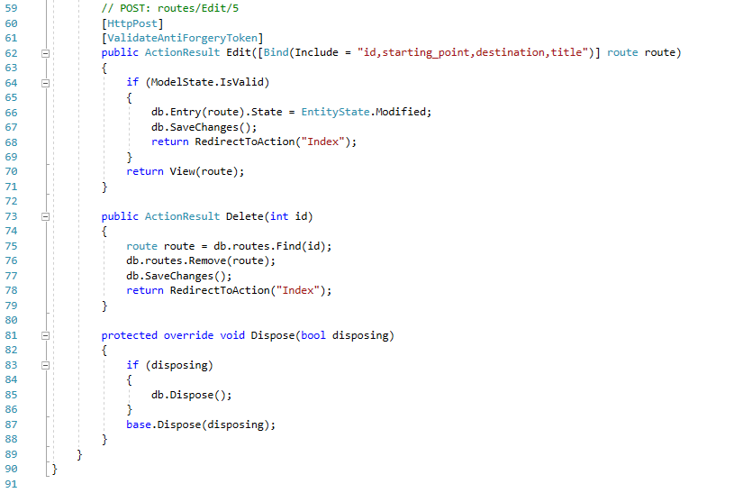

### **Schedules**

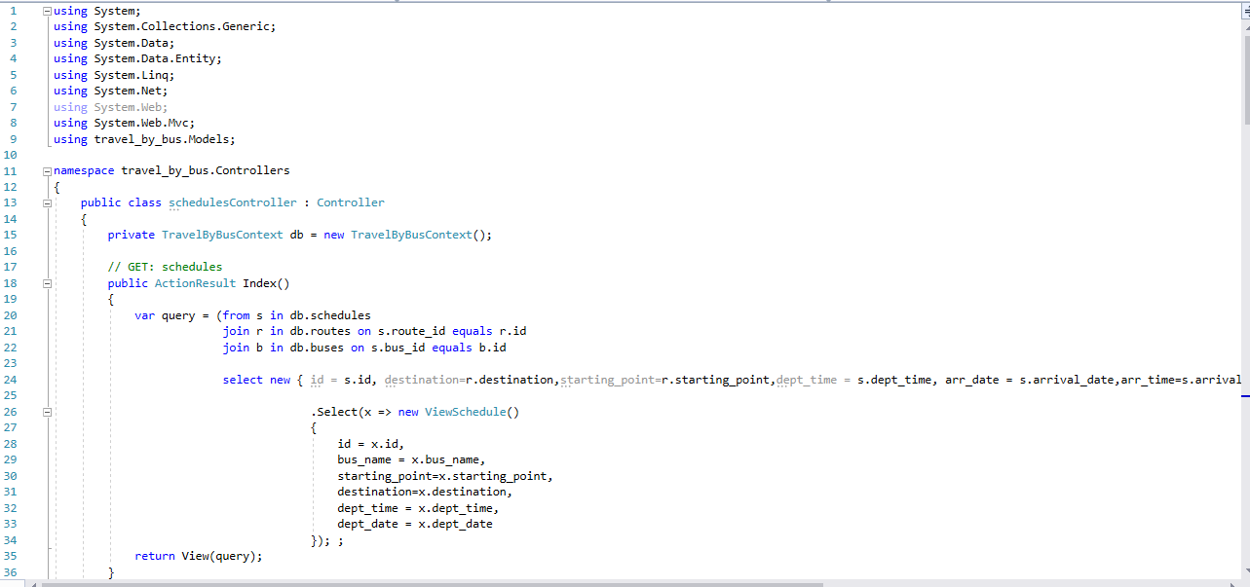

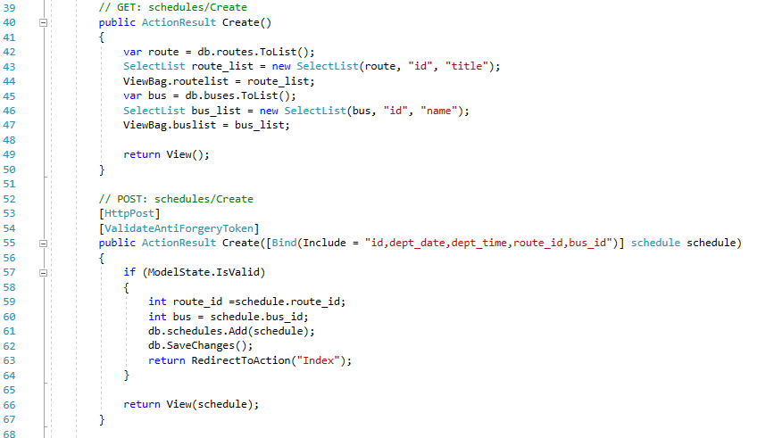

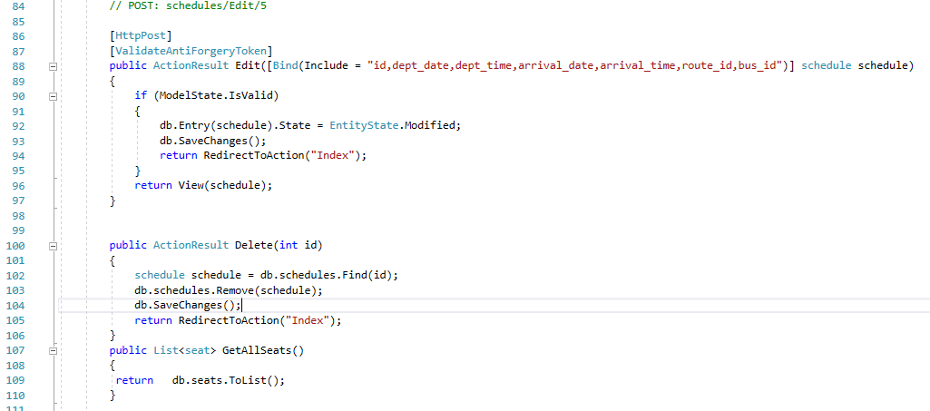

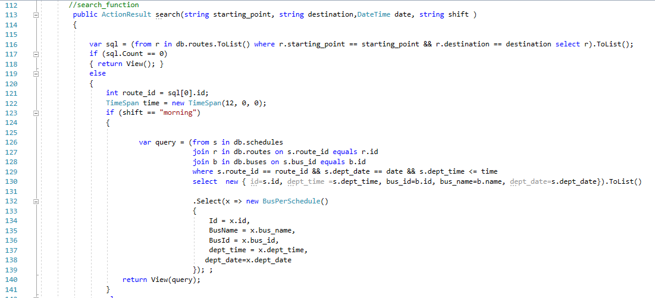

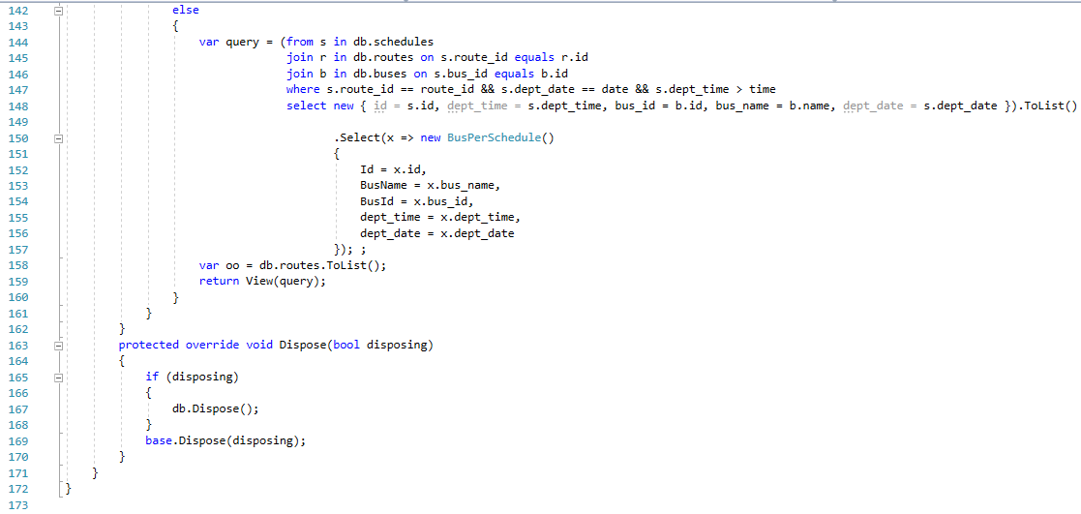

### **seats**

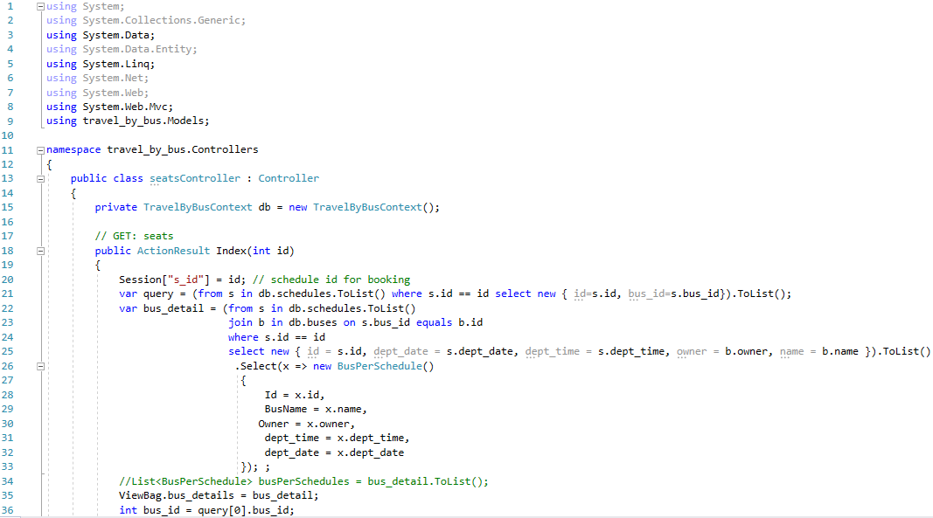

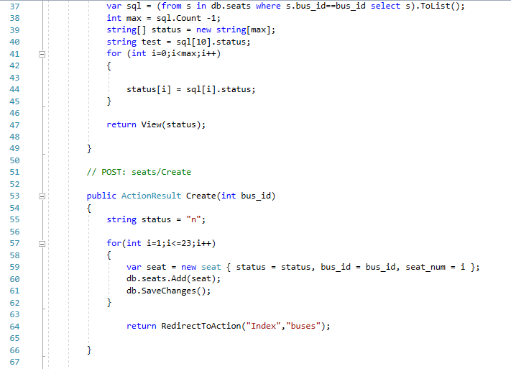

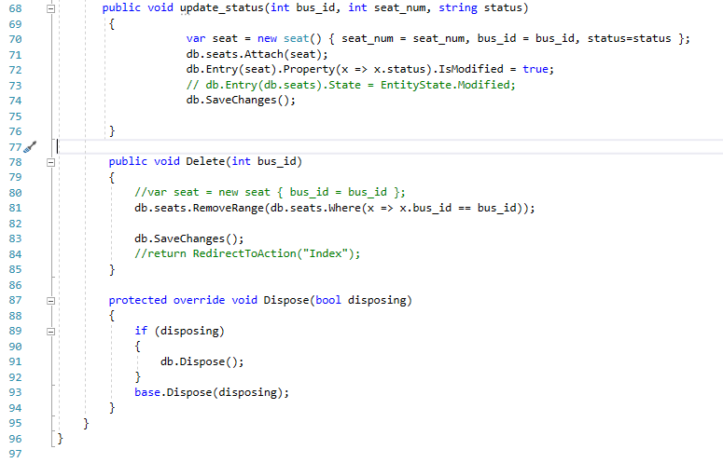

### **users**

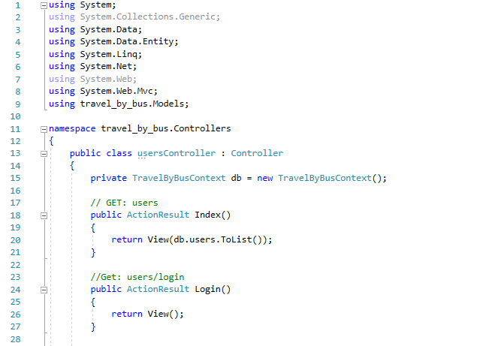

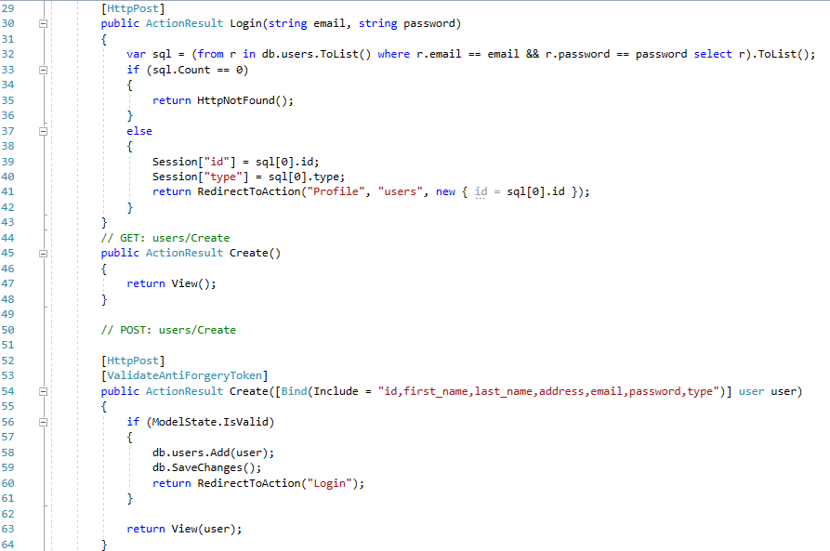

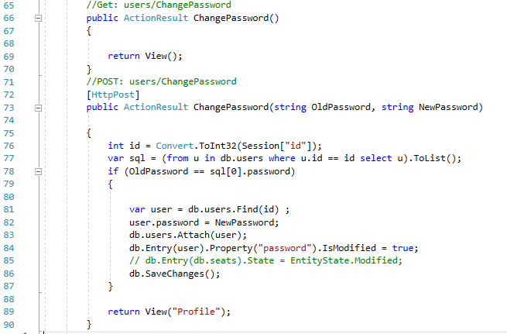

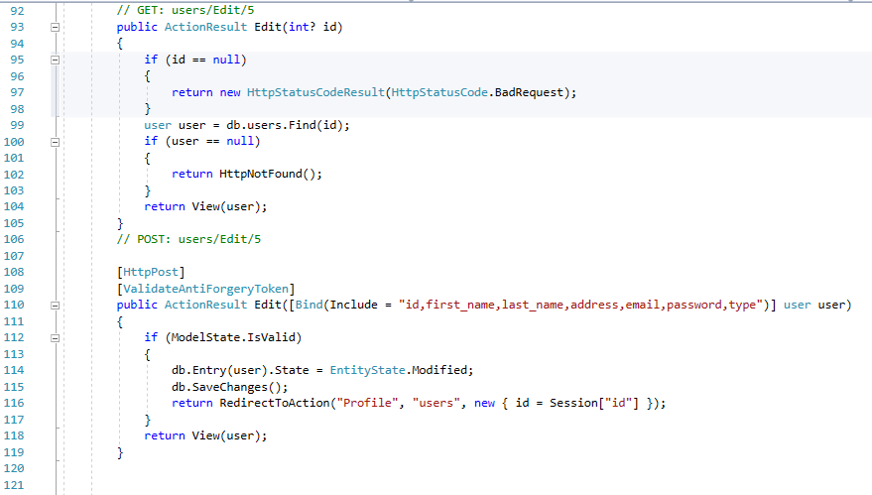

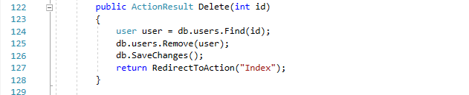

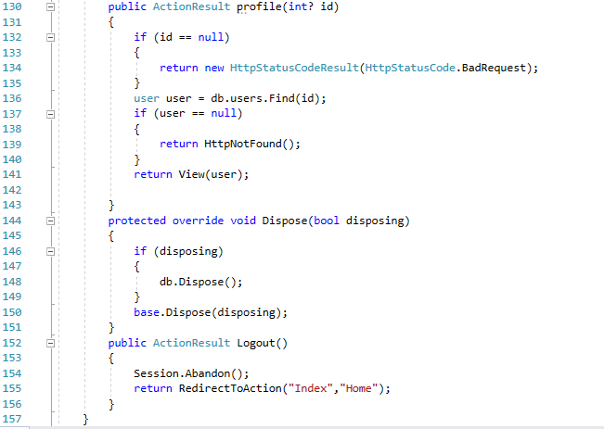

## **View**

### **_Layout.cshtml**

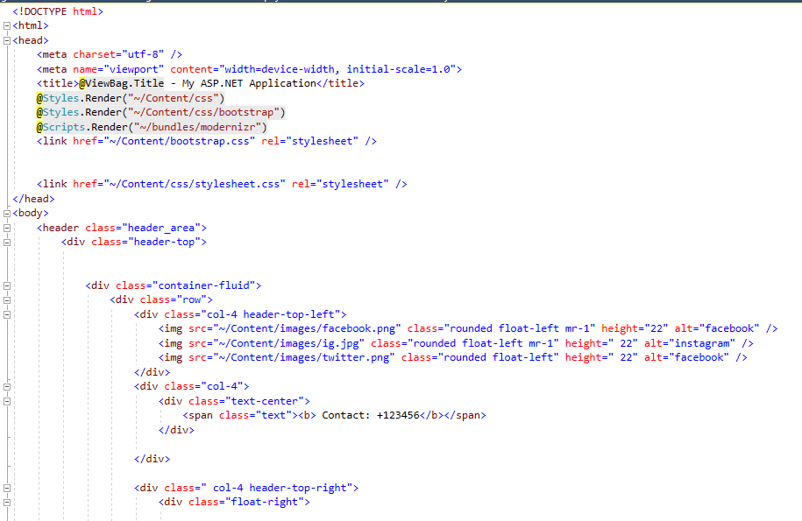

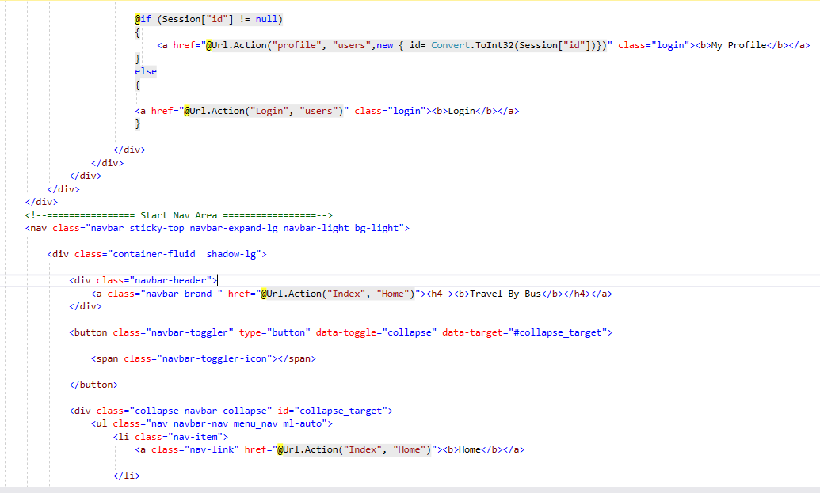

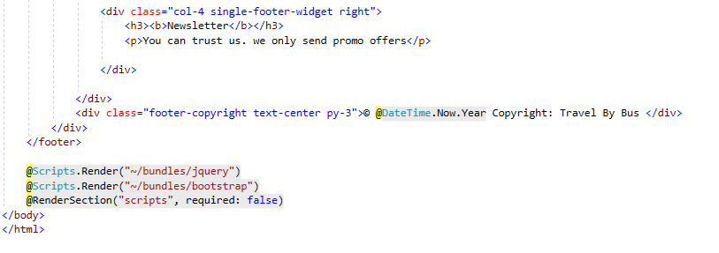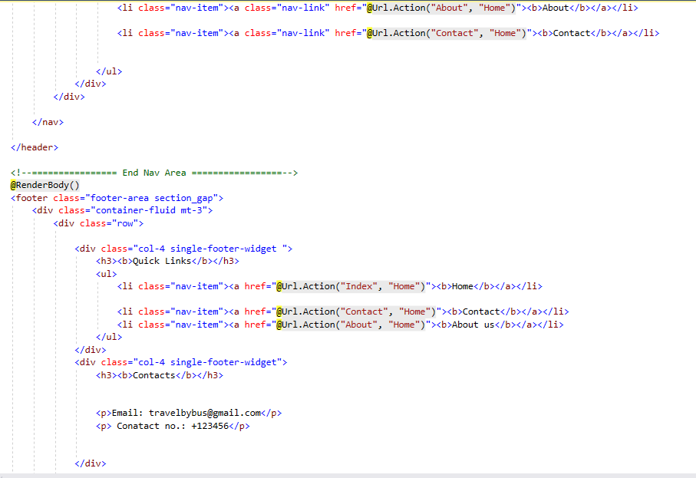

### **Booking**

**BookingPerUser.cshtml**

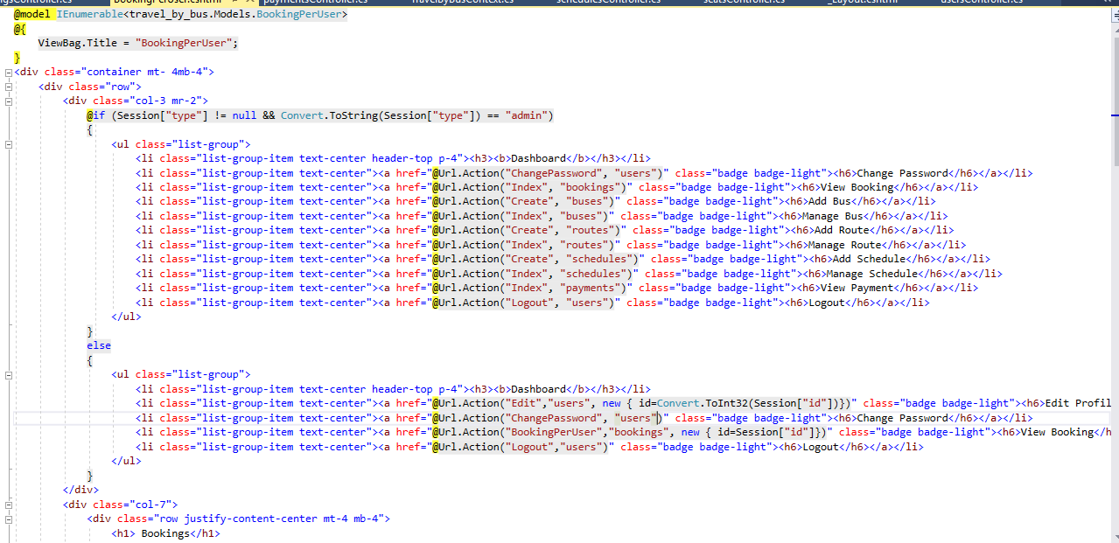

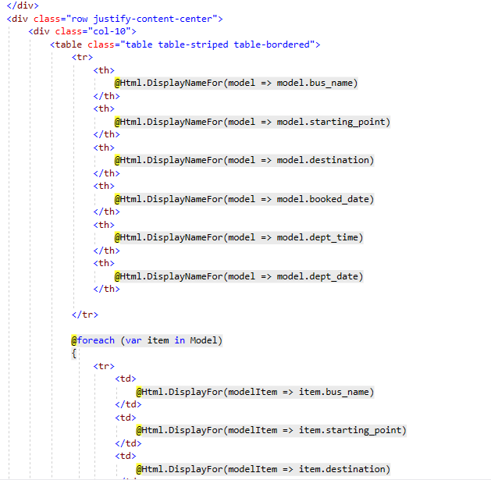

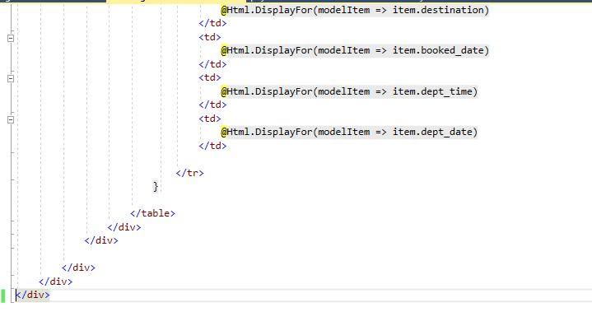

**Index.cshtml**

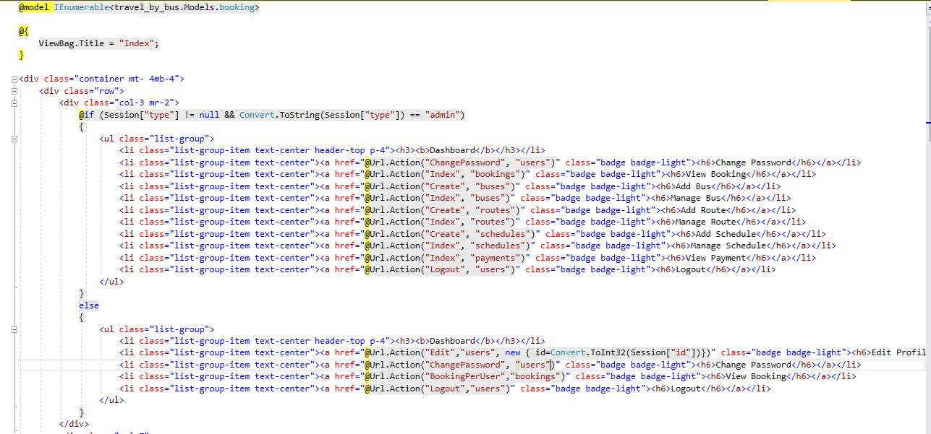

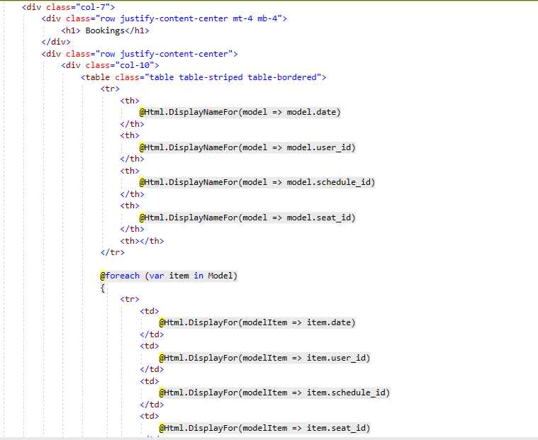

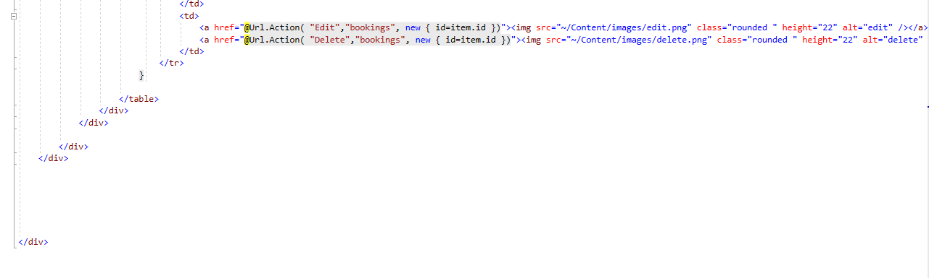

### **buses**

**Create**

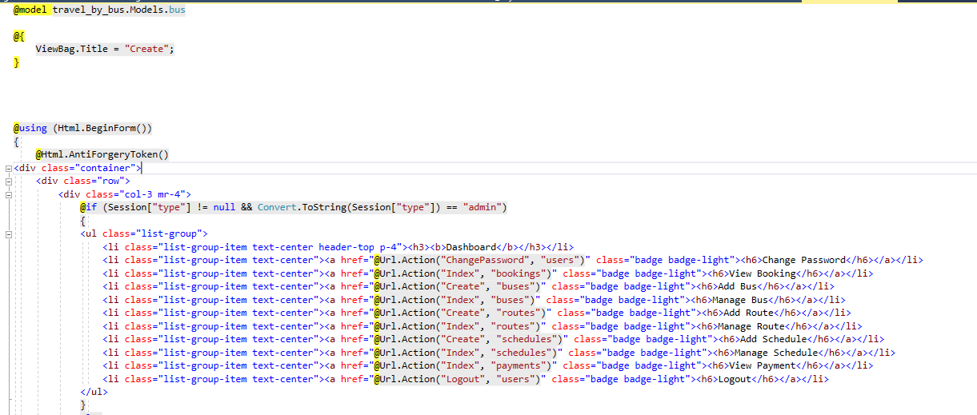

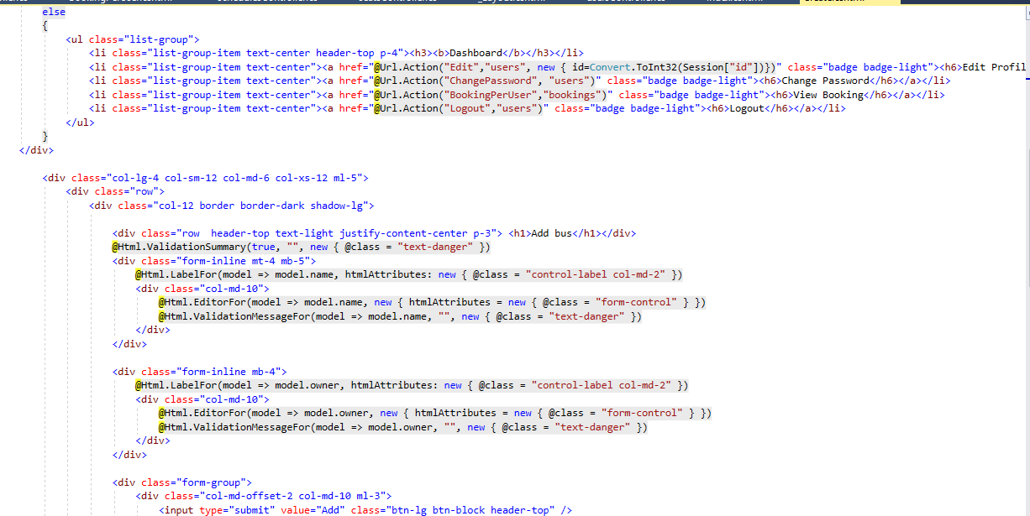

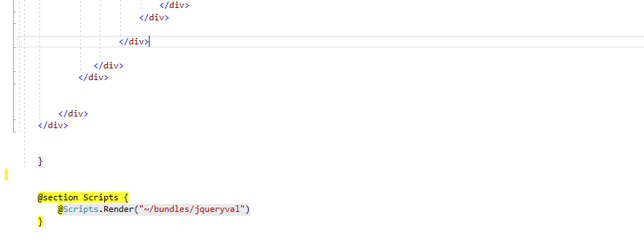

**Edit.cshtml**

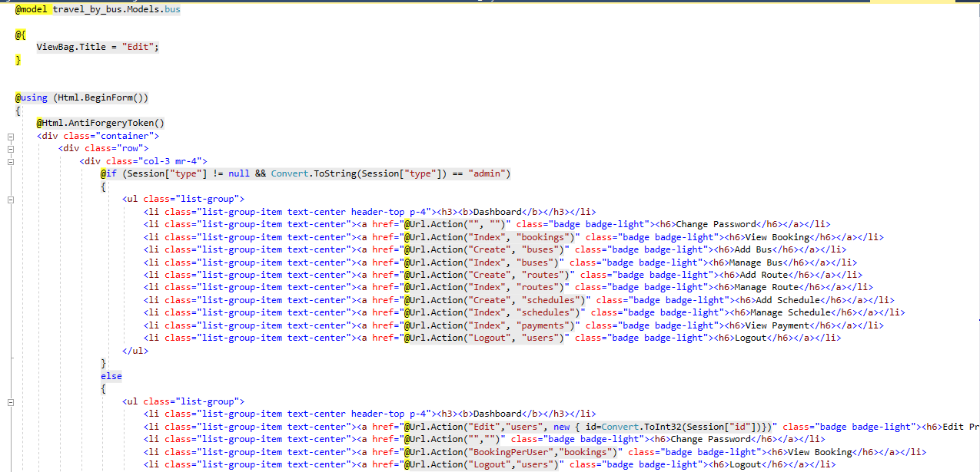

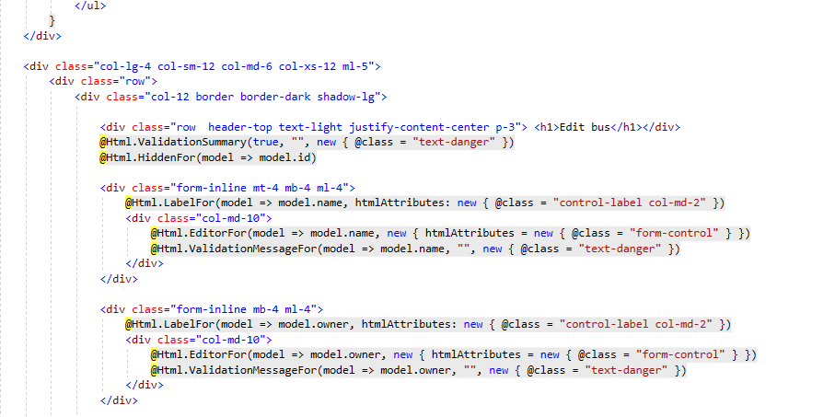

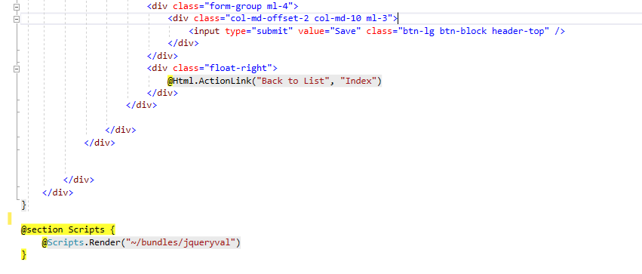

**Index.cshtml**

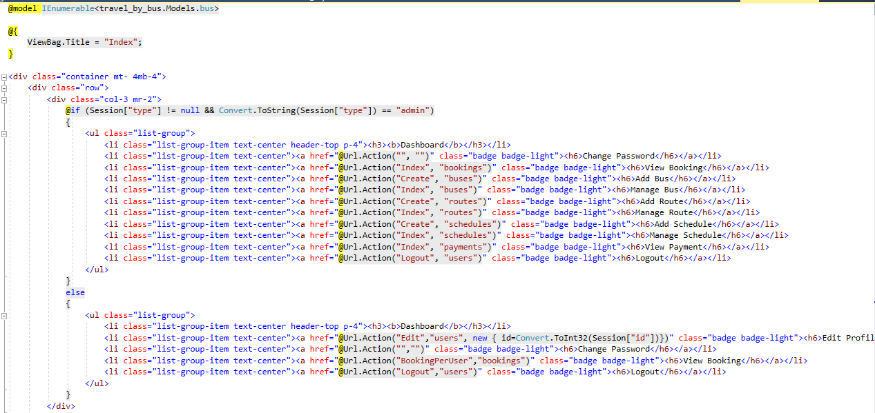

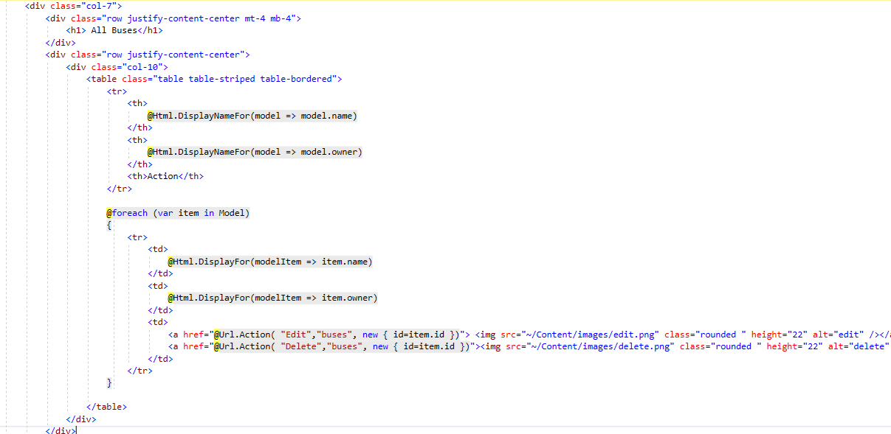

### **schedules**

**Create.cshtml**

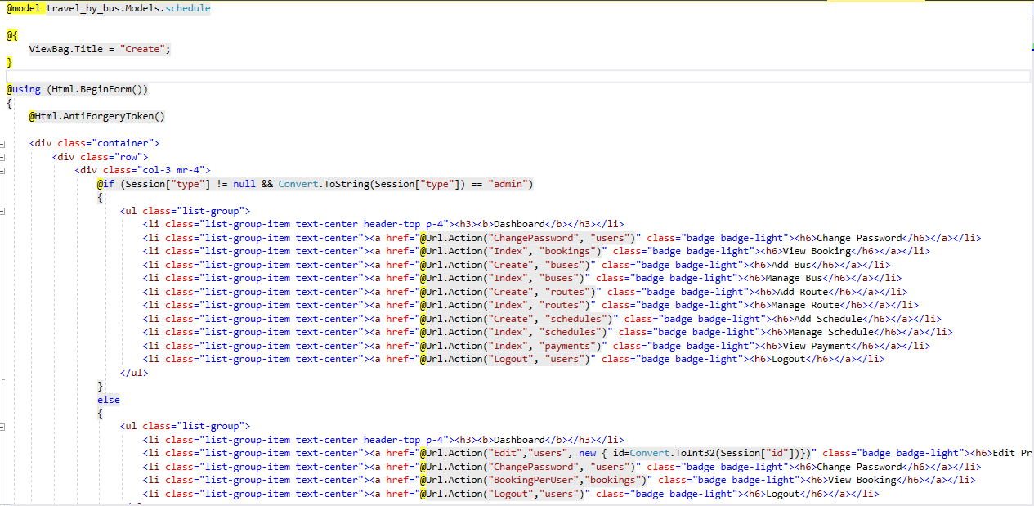

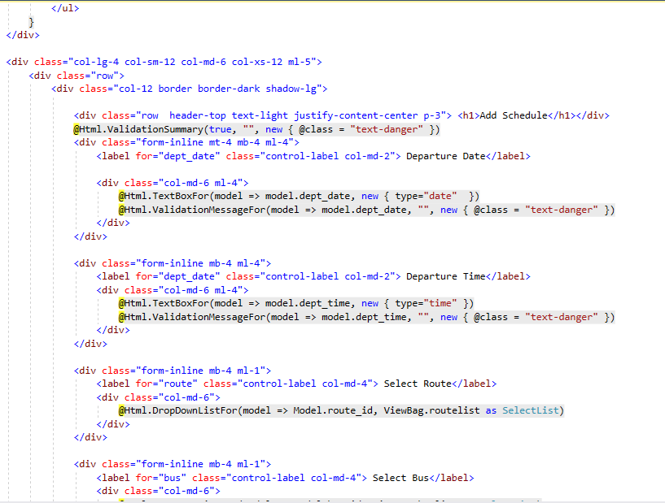

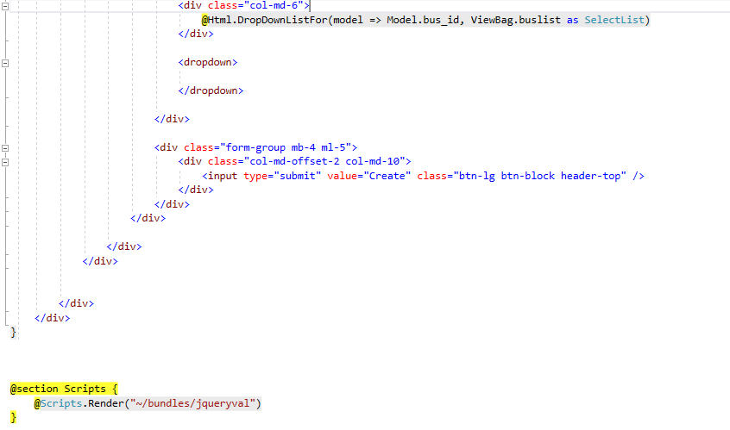

**Edit.cshtml**

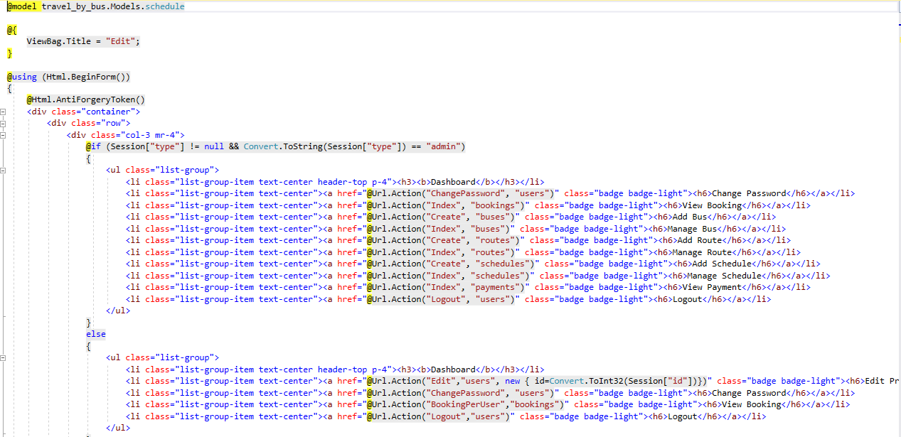

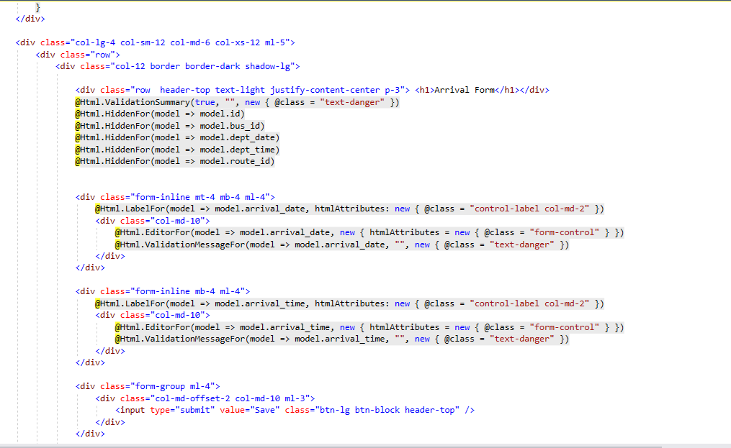

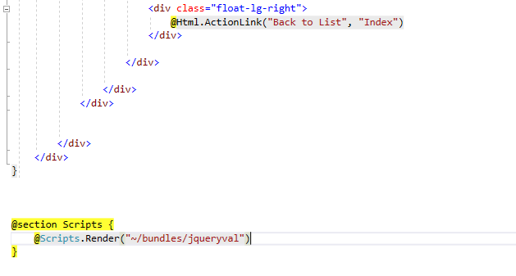

**Index.cshtml**

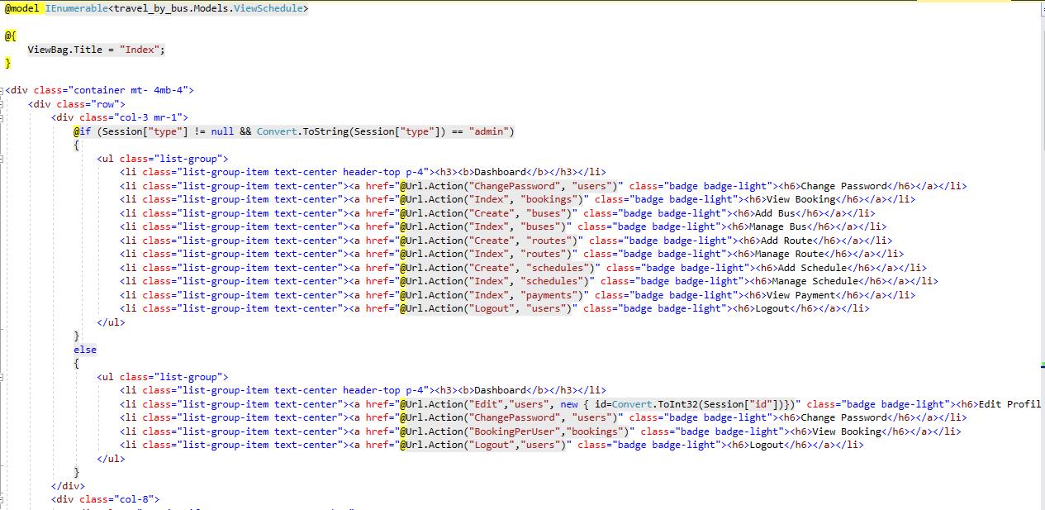

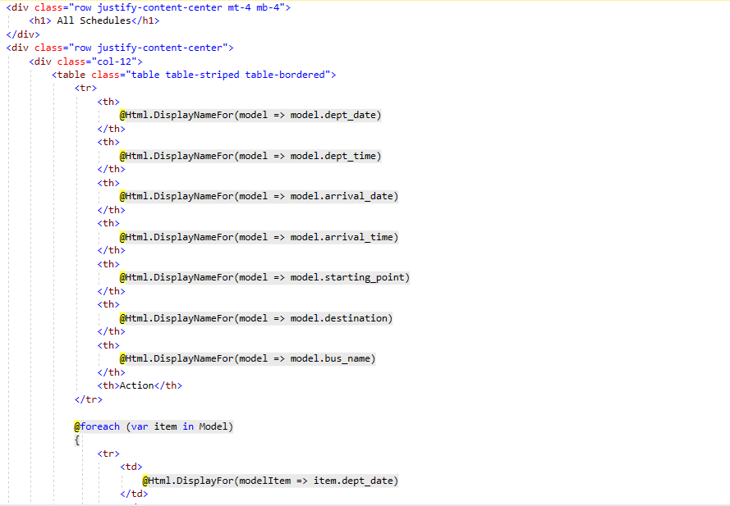

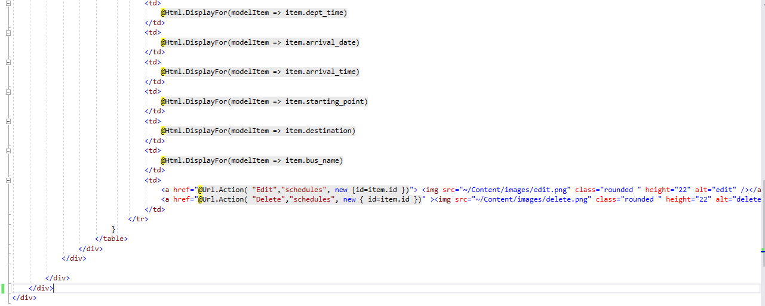

### **payments**

**Create.cshtml**

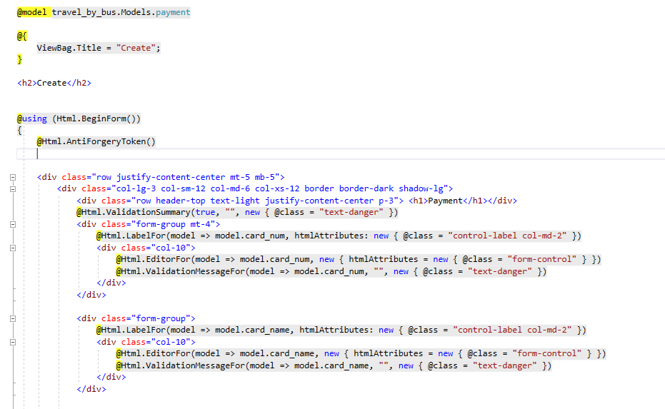

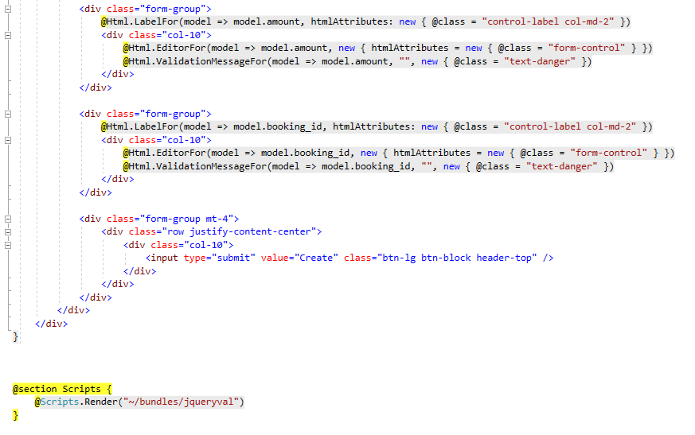

**Index.cshtml**

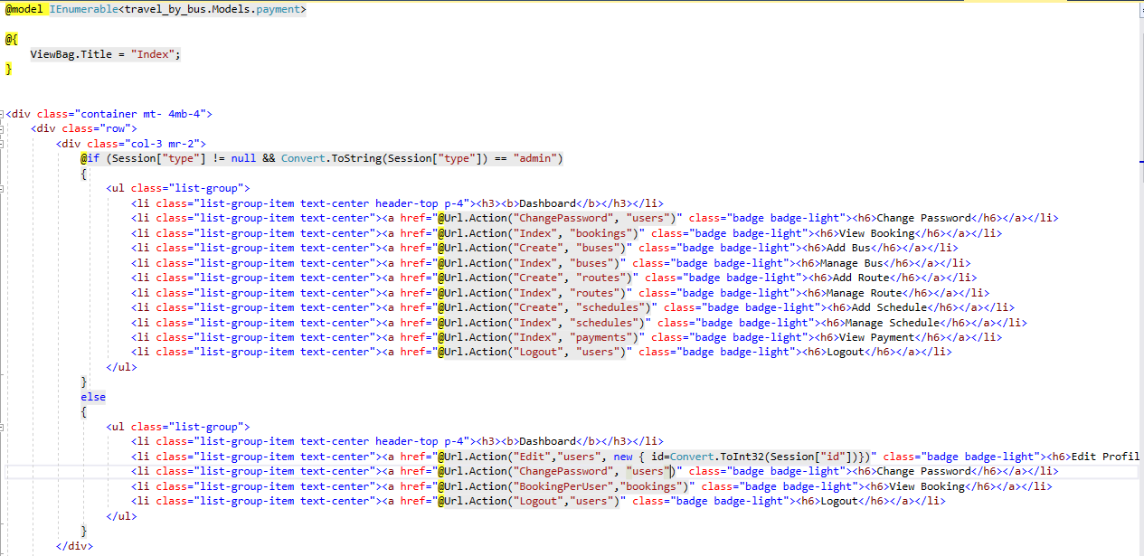

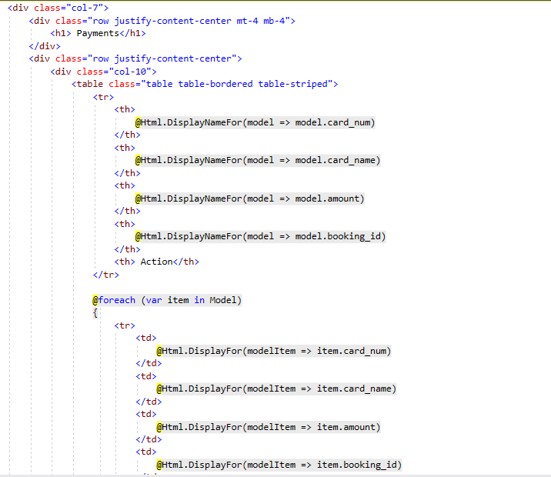

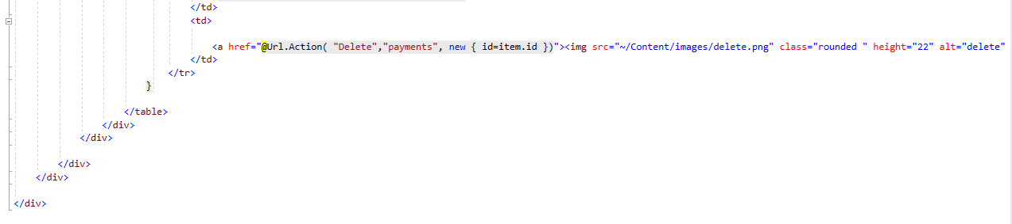

### **seats**

**Index.cshtml**

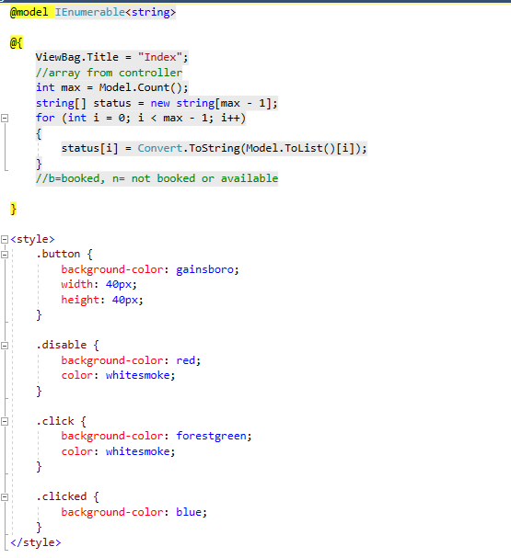

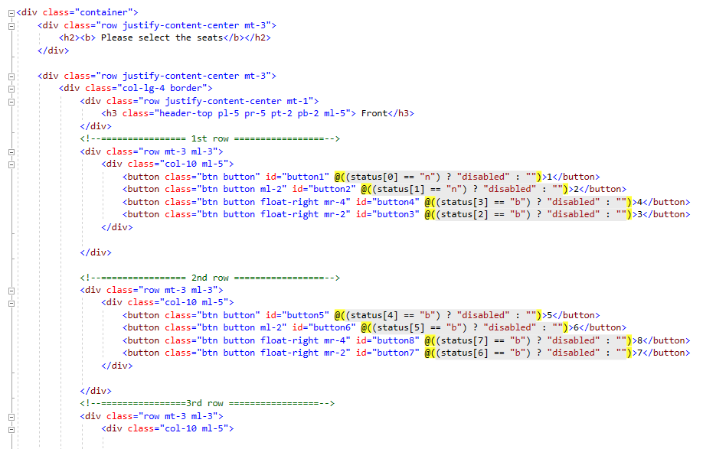

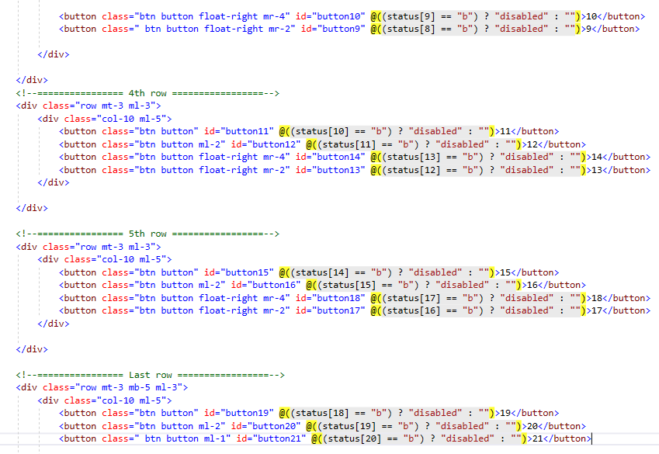

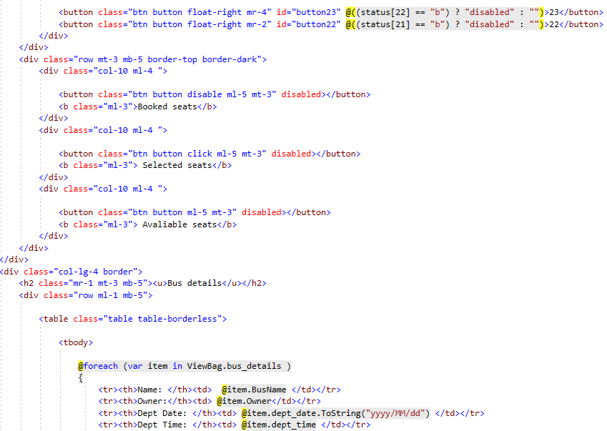

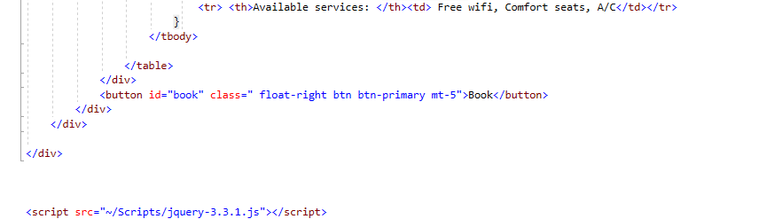

### **route**

**Create.cshtml**

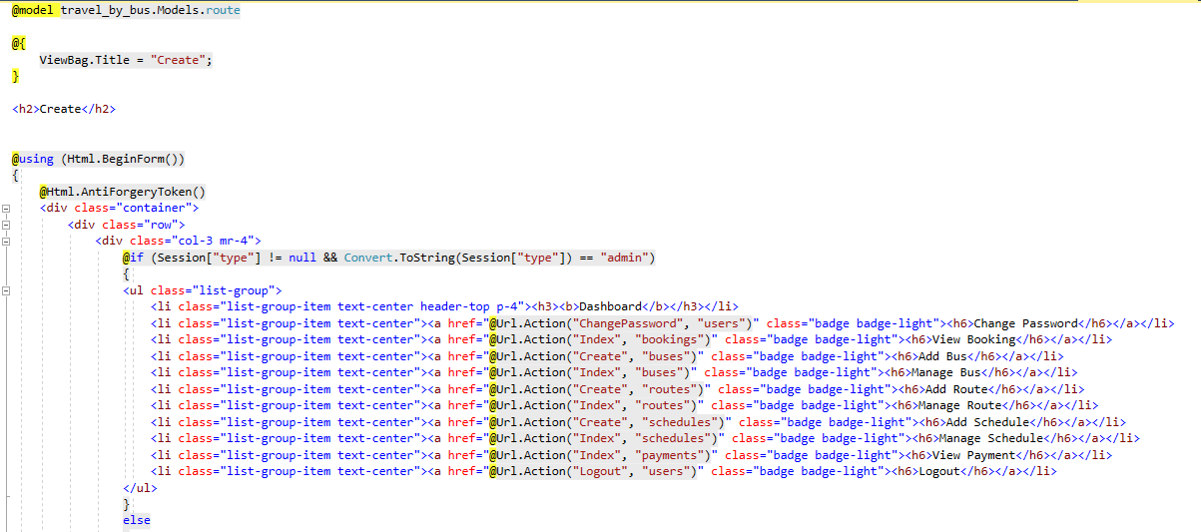

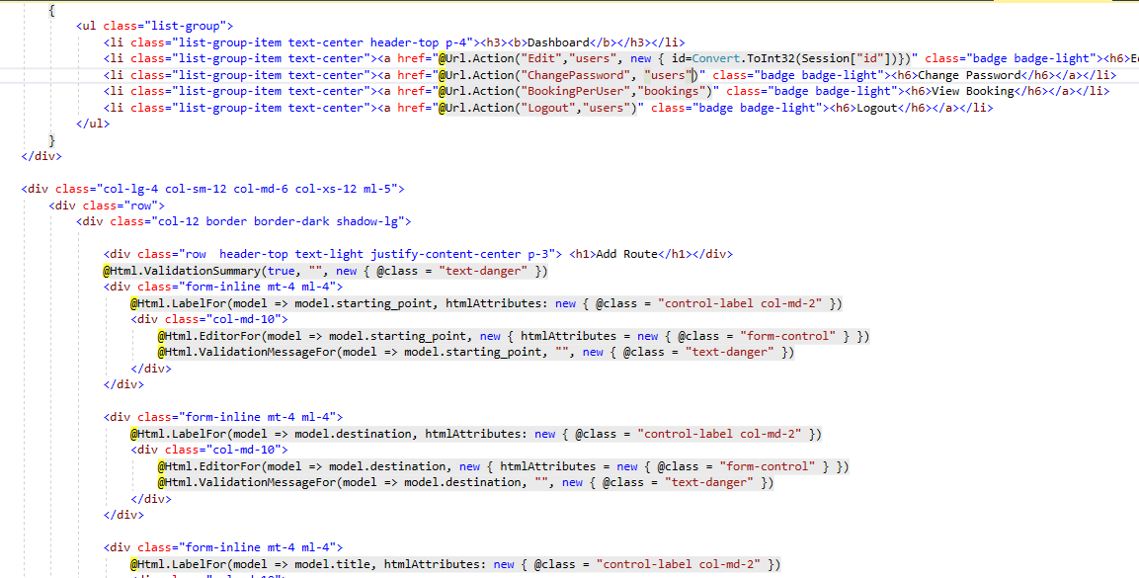

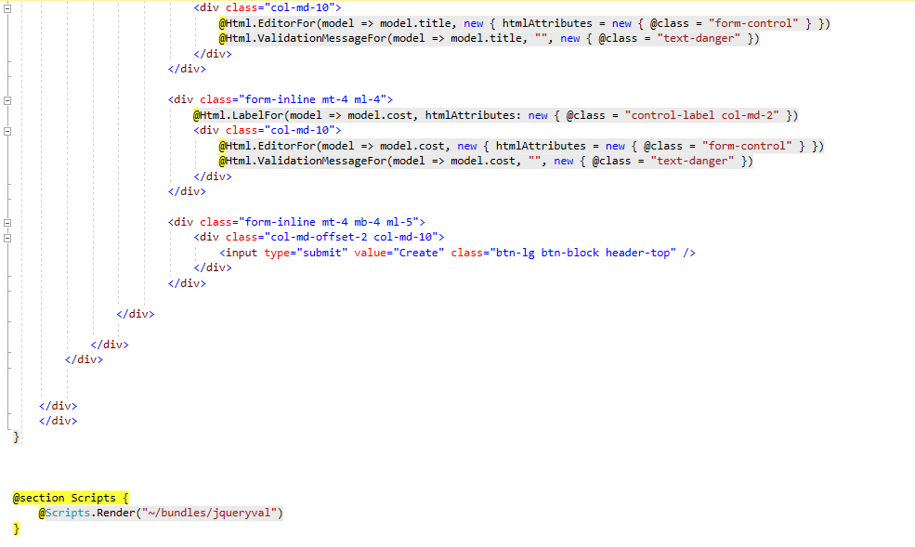

**Edit.cshtml**

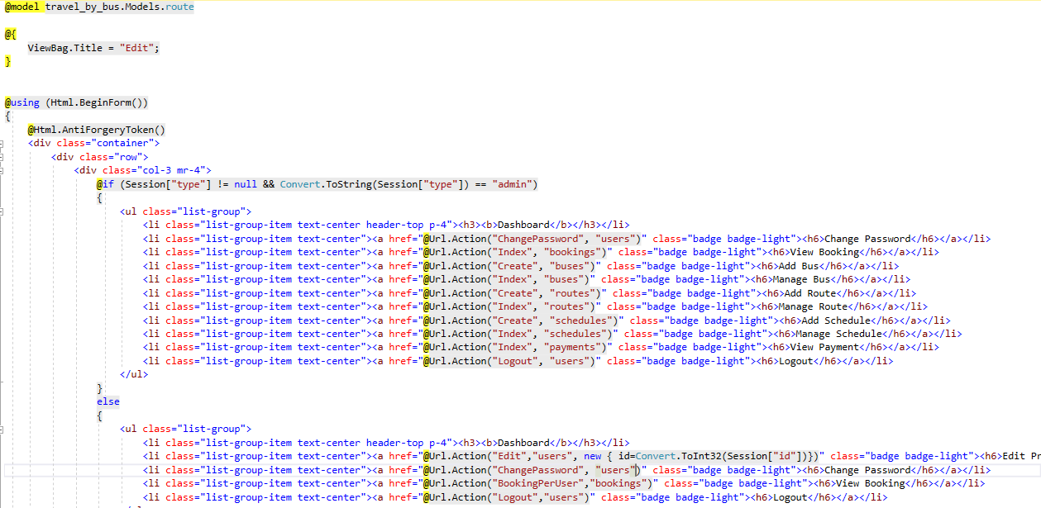

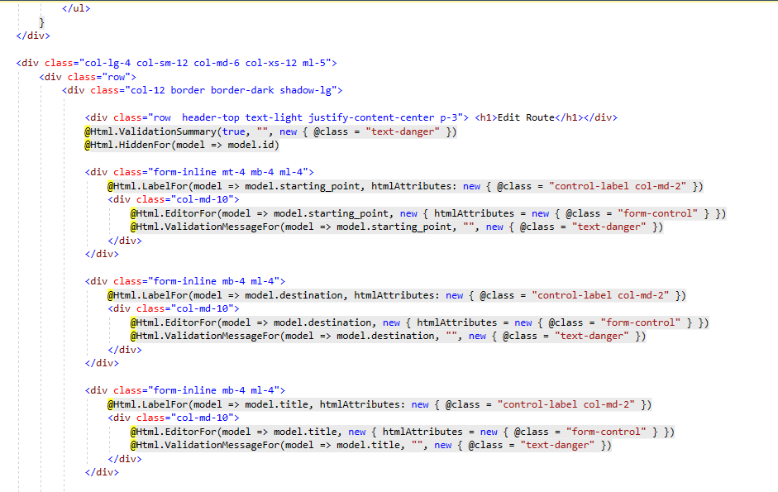

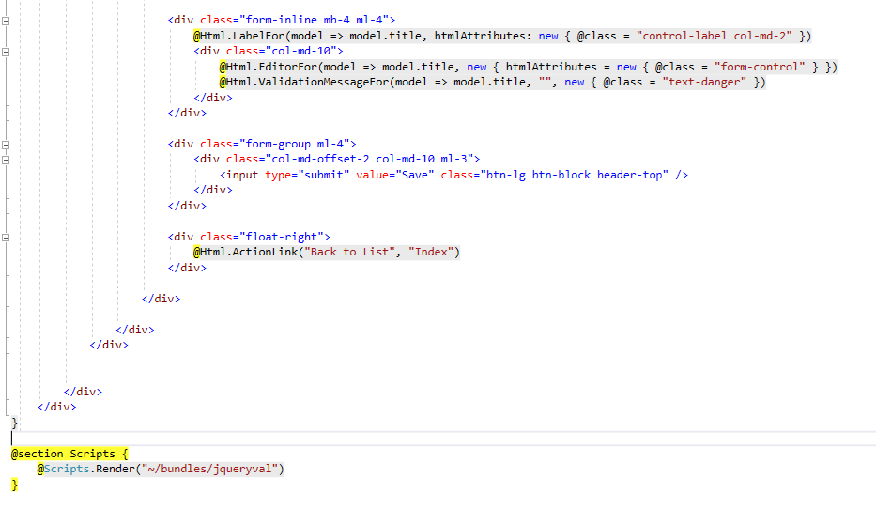

**Index.cshtml**

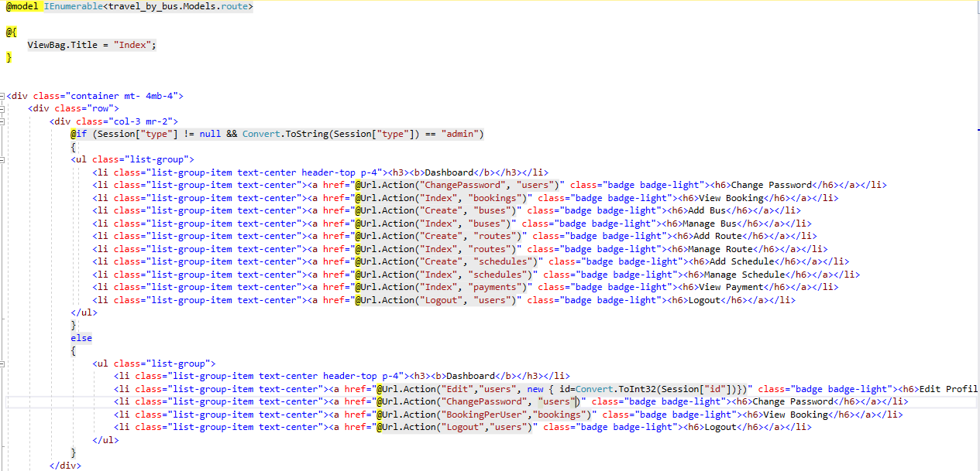

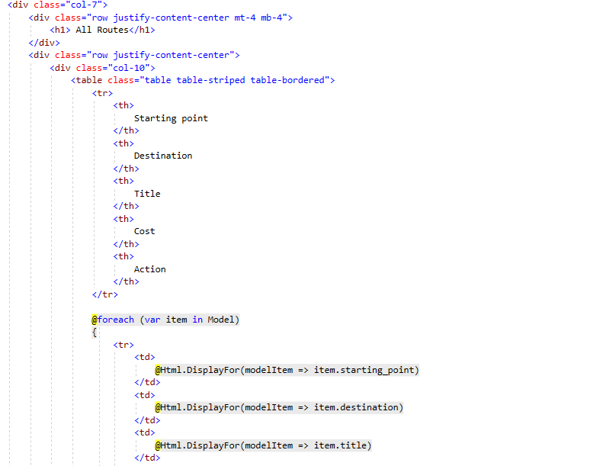

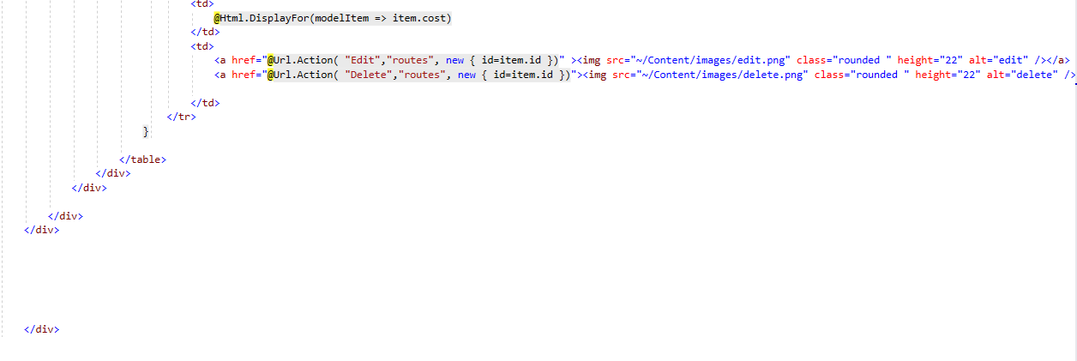

### **Home**

**About.cshtml**

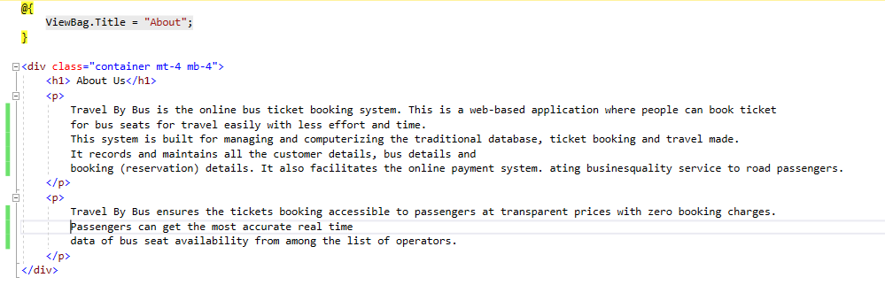

**Contact.cshtml**

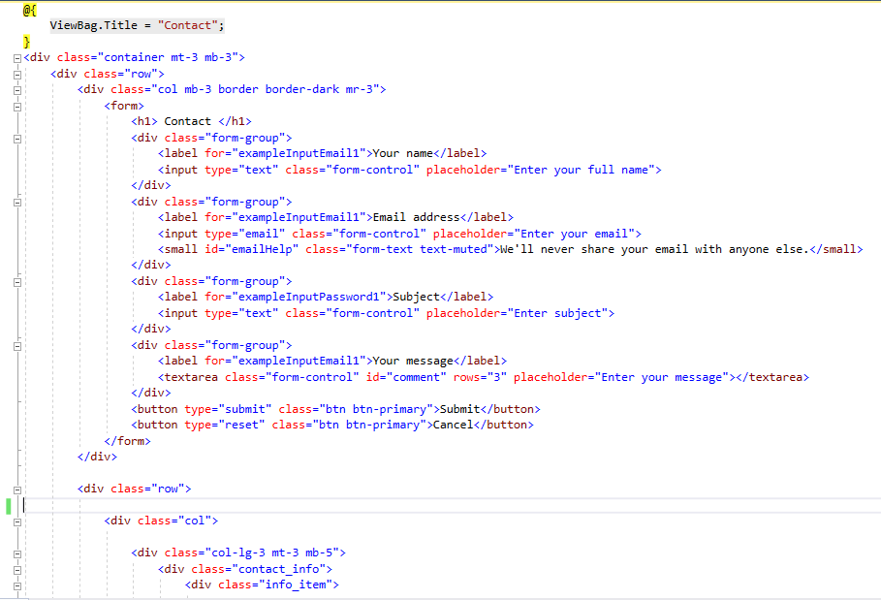

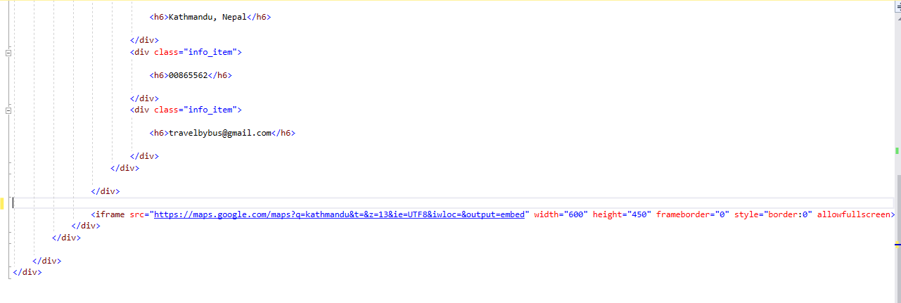

**Index.cshtml**

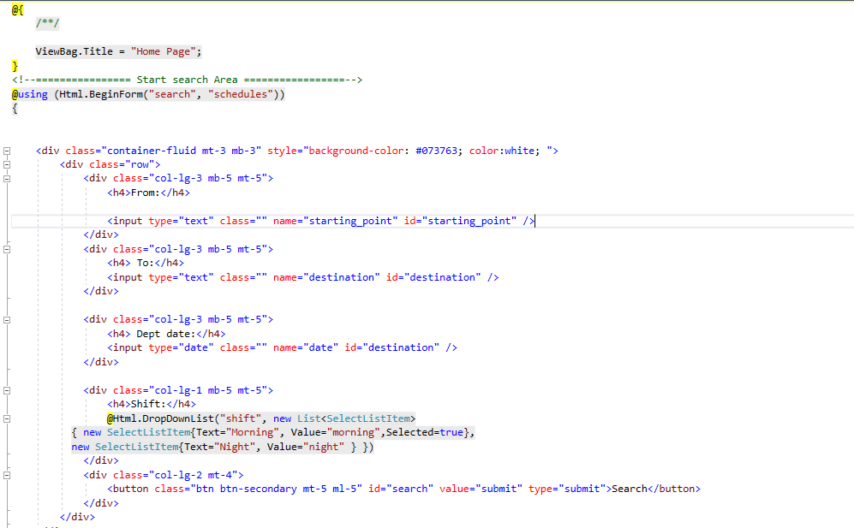

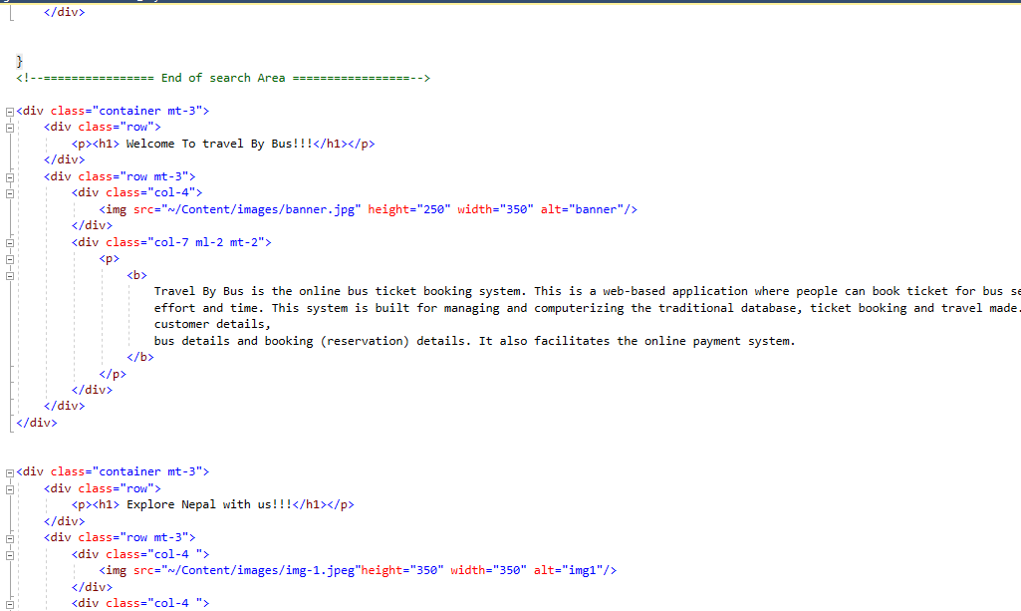

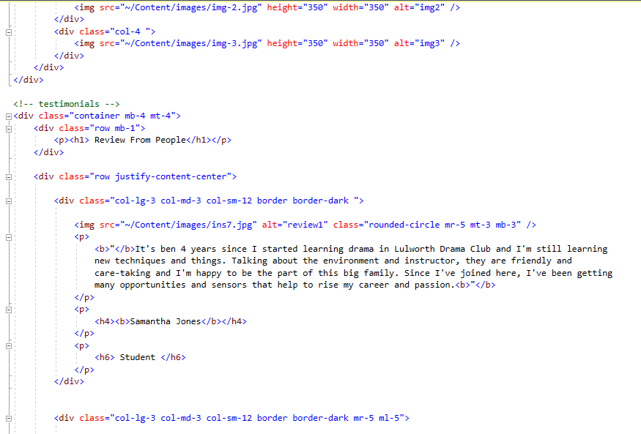

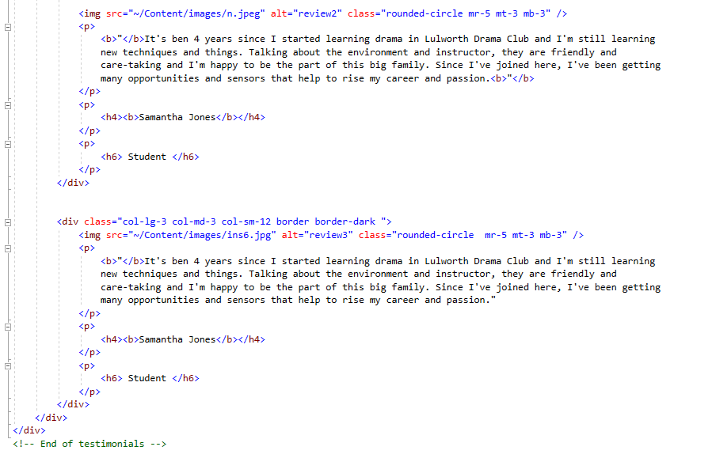

### **Users**

**Create.cshtml**

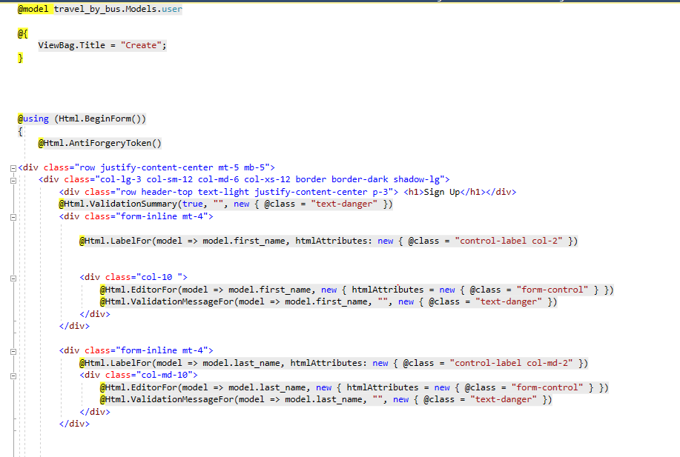

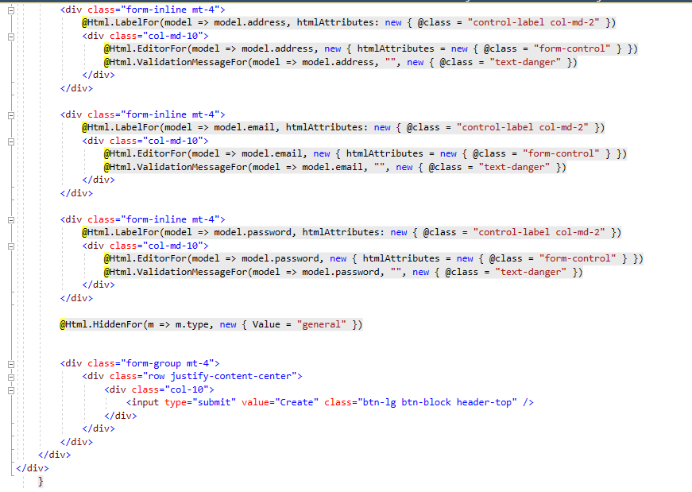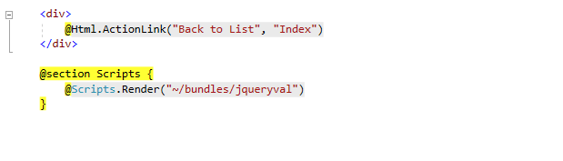

**ChangePassword.cshtml**

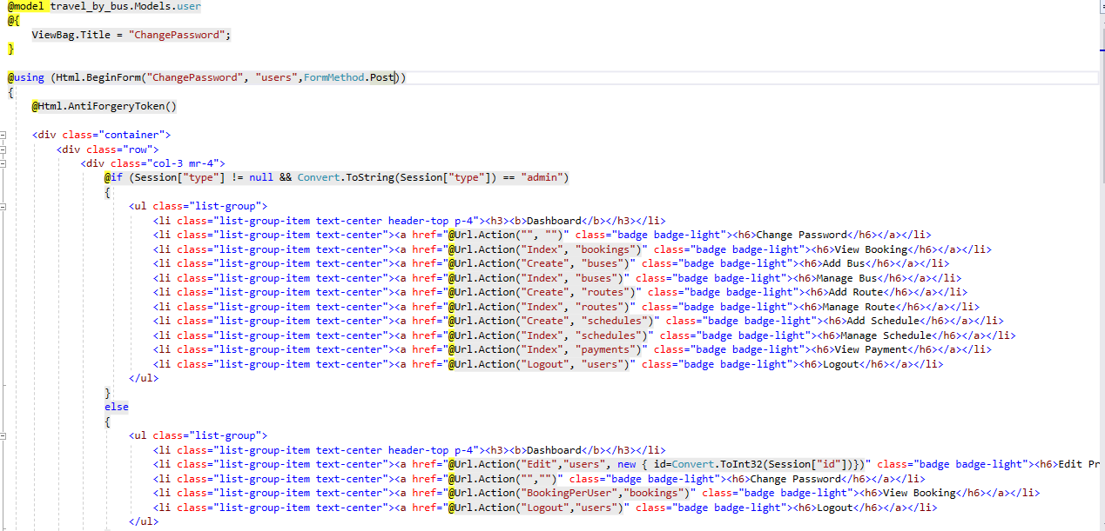

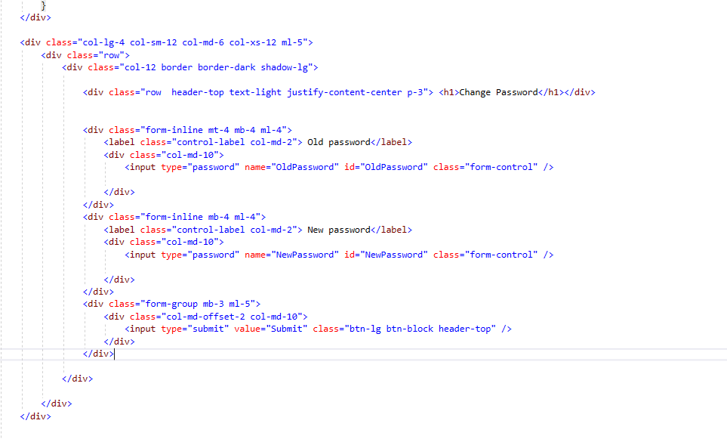

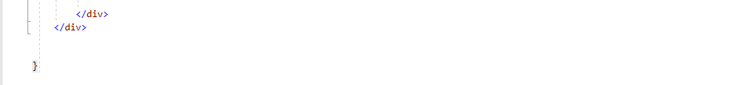

**Edit.cshtml**

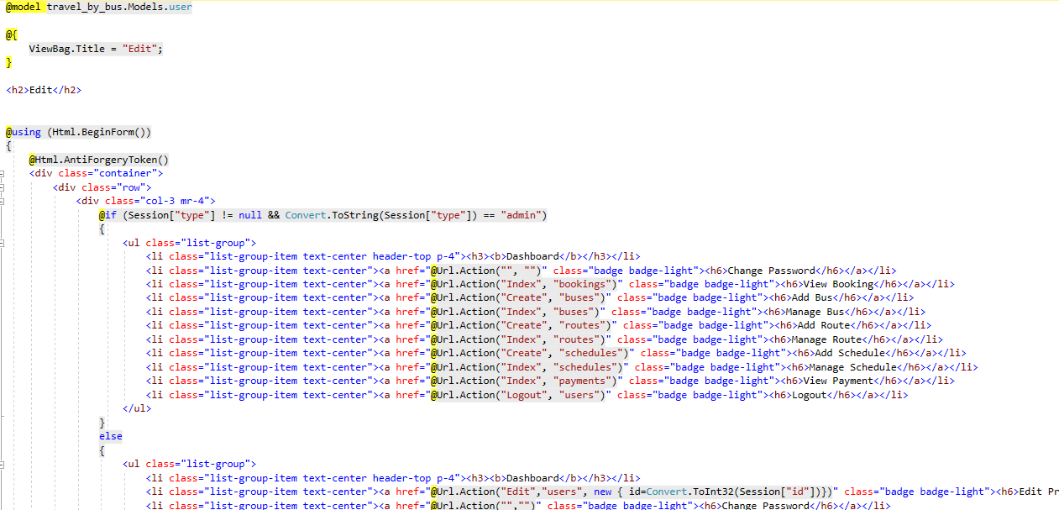

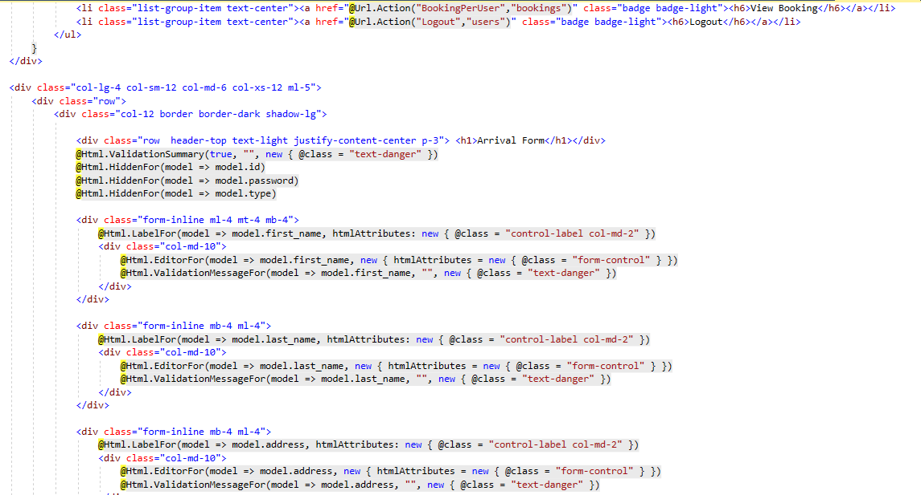

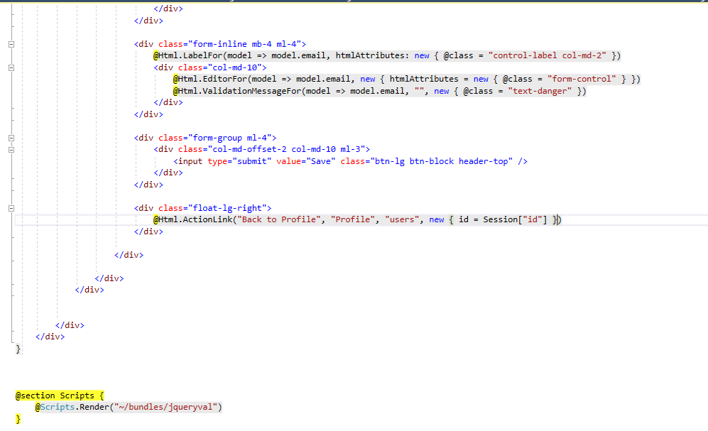

**Login.cshtml**

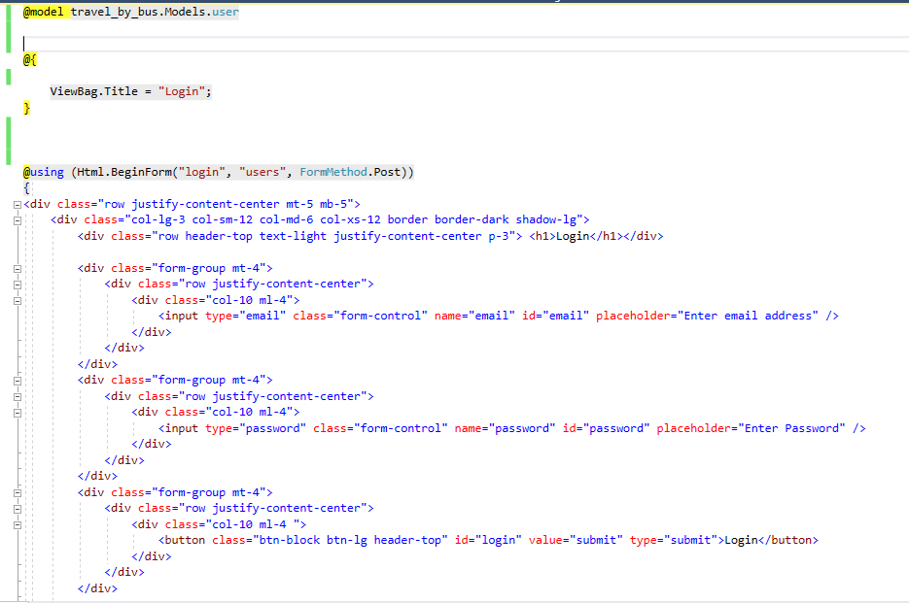

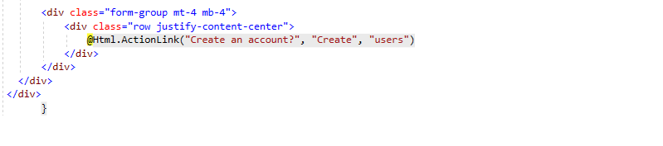

**Index.cshtml**

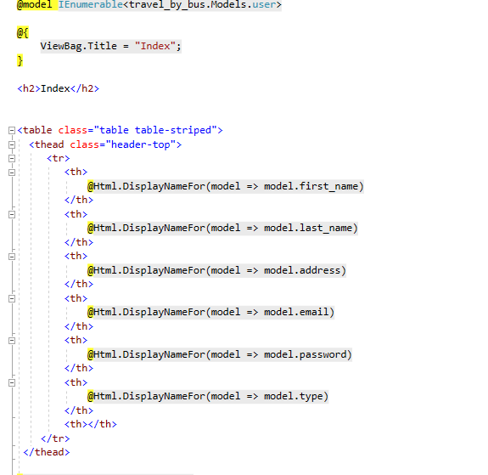

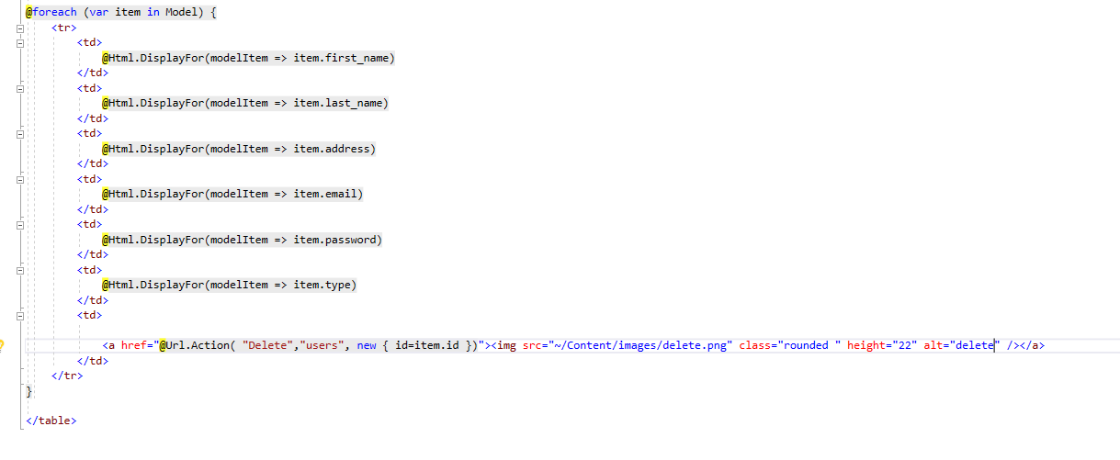

**Profile.cshtml**

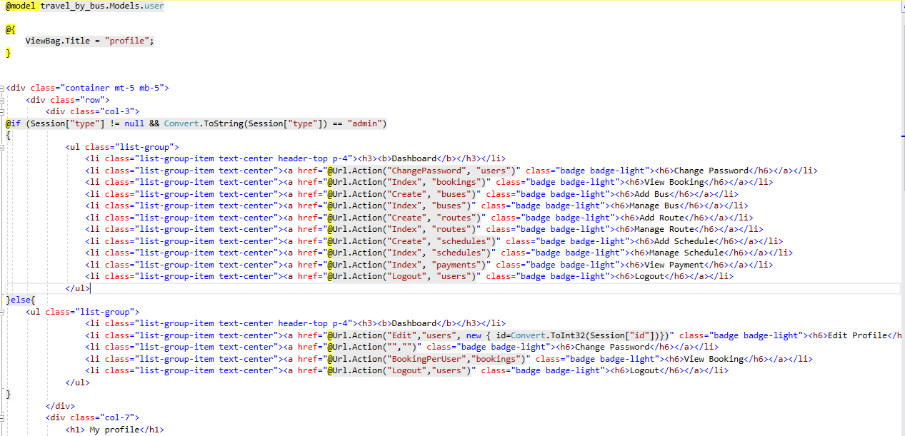

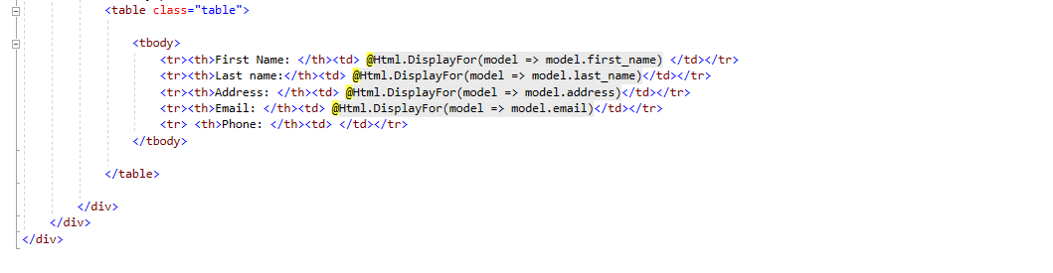

# **Chapter 5: Testing**

## **5.1 Introduction**

## Testing is the phase where we focus on investigation and discovery. This phase comes after the implementation phase. In this phase, the coding done in implementation phase is tested to ensure that it is working accordingly to the customer requirements. This phase helps to make the system bug-free, more user-friendly, and more efficient. It ensures the quality of the software and the functionalities developed are working as requirements.

## There are many types of testing like Integration testing, Usability testing, user-acceptance testing and so on. Among them, I am preforming Black box testing and unit testing for the project.

## **5.2 Testing types**

### **Black box testing**

Black box testing as known as "**Behavioral Testing**" is the method of software testing where testing is done on the basis of input and output. In this testing, tester does not know what is going inside the system as the internal structure of code is not known to tester.

**Test Case: Empty field testing**

|  |  |  |  |  |
| --- | --- | --- | --- | --- |
| **Form/Object** | **Input** | **Expected result** | **Actual result** | **Remarks** |
| Bus registration | empty | Error message should be displayed. | Error message is displayed. | Pass |

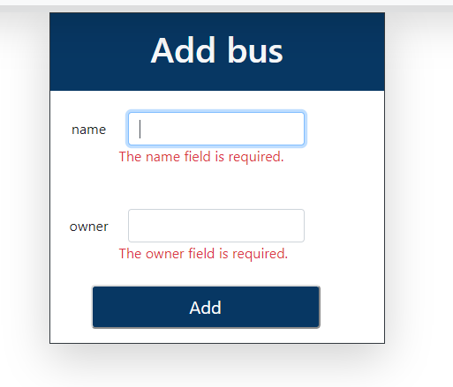

Fig: Actual result

**Test Case: Invalid email testing**

|  |  |  |  |  |
| --- | --- | --- | --- | --- |
| **Form/Object** | **Input** | **Expected result** | **Actual result** | **Remarks** |
| User registration | Invalid email format | Error message should be displayed. | Error message is displayed. | Pass |

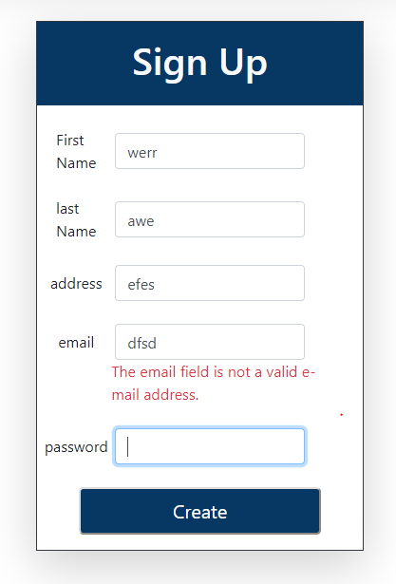

Fig: Actual result

**Test Case: Admin Login**

|  |  |  |  |  |
| --- | --- | --- | --- | --- |
| **Form/Object** | **Input** | **Expected result** | **Actual result** | **Remarks** |
| Login | Username and password | After entering valid input, redirect to admin profile. | After entering valid input, it is redirected to admin profile. | Pass |

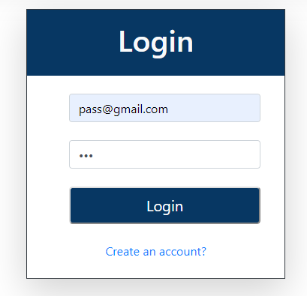

Fig: Input

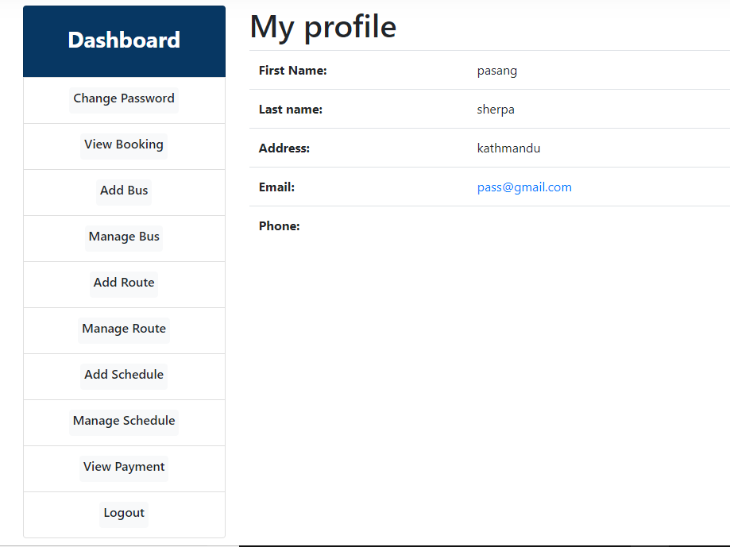

Fig: Actual result

**Test Case: User Login**

|  |  |  |  |  |
| --- | --- | --- | --- | --- |
| **Form/Object** | **Input** | **Expected result** | **Actual result** | **Remarks** |
| Login | Username and password | After entering valid input, redirect to user profile. | After entering valid input, it is redirected to user profile. | Pass |

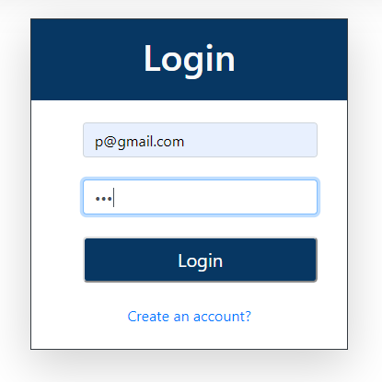

Fig: Input

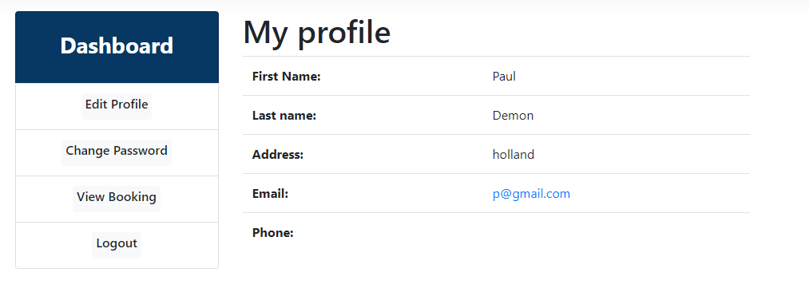

Fig: Actual result

**Test Case: Edit Profile**

|  |  |  |  |  |
| --- | --- | --- | --- | --- |
| **Form/Object** | **Input** | **Expected result** | **Actual result** | **Remarks** |
| Edit Profile | Required details | After submitting required details, profile should be updated. | Profile is update successfully. | Pass |

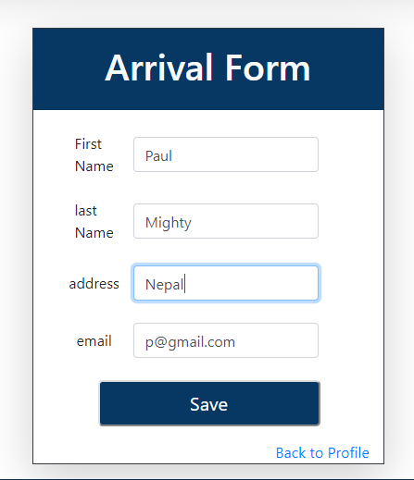

Fig: Input for edit profile

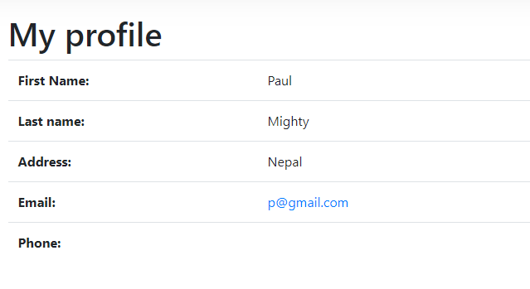

Fig: Actual Output

**Test Case: Add Route**

|  |  |  |  |  |
| --- | --- | --- | --- | --- |
| **Form/Object** | **Input** | **Expected result** | **Actual result** | **Remarks** |
| Add route | Required details | After submitting required details, route should be added. | Route is added. | Pass |

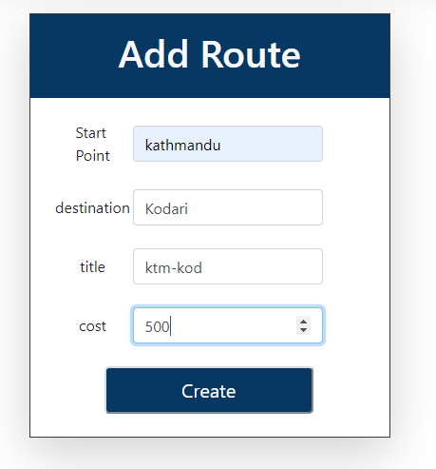

Fig: Input

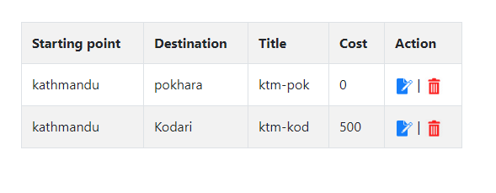

Fig: Actual output

**Test Case: Edit Route**

|  |  |  |  |  |
| --- | --- | --- | --- | --- |
| **Form/Object** | **Input** | **Expected result** | **Actual result** | **Remarks** |
| Edit route | Required details | After submitting required details, route should be updated. | Route is updated successfully. | Pass |

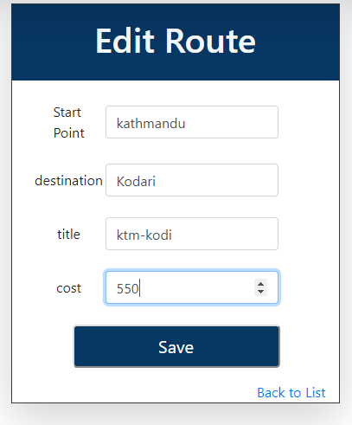

Fig: Input for edit

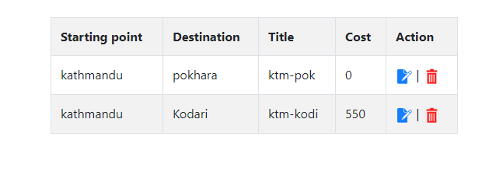

Fig: Actual result

### **Unit testing**

Unit testing is the method of testing in which individual components of the system are being tested. The main purpose of this testing is to validate each unit of the system performs as designed. It is performed by using **White box testing**.

* **Booking Per User**

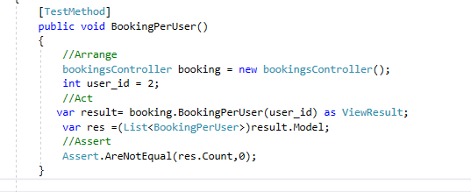

**Output:**

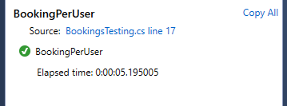

* **Booking Per User is null**

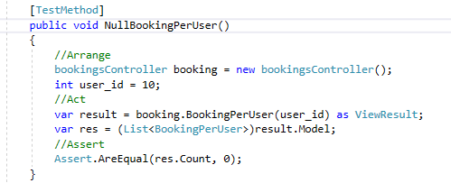

**Output:**

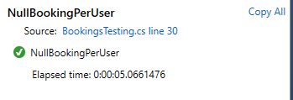

* **Create bus**

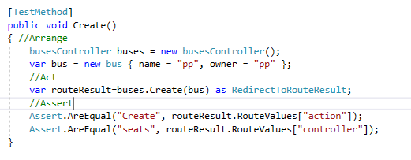

**Output:**

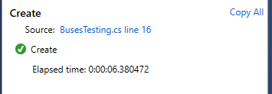

* **Create route**

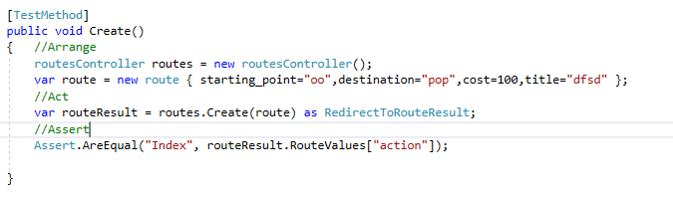

**Output:**

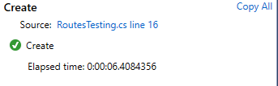

* **View Schedule**

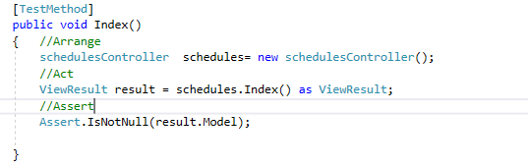

**Output:**

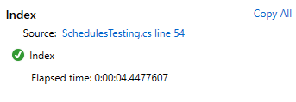

* **Schedule search found**

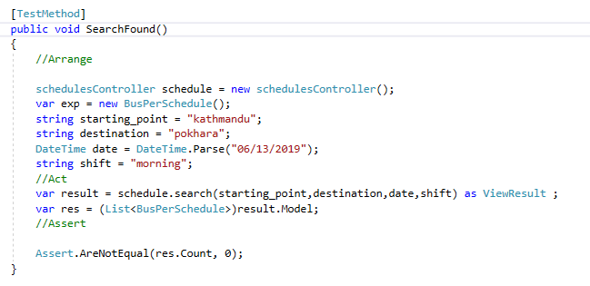

**Output:**

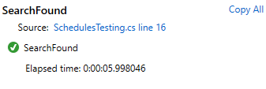

* **Schedule search null**

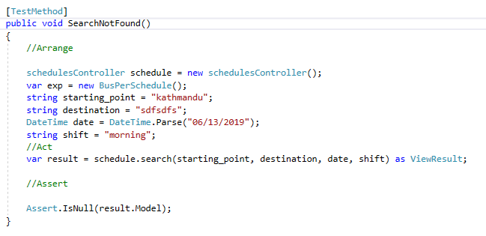

**Output:**

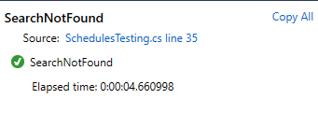

* **Change seat**

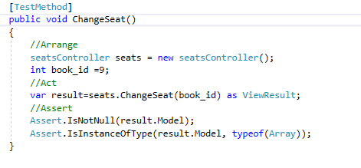

**Output:**

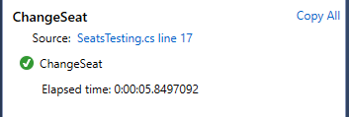

* **Login successful**

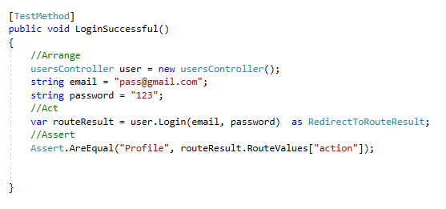

**Output:**

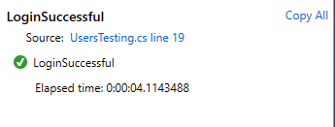

* **Login Unsuccessful**

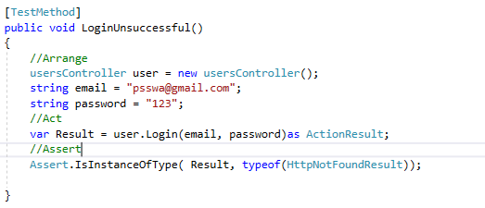

**Output:**

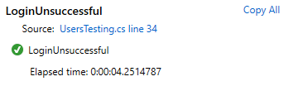

* **View Routes**

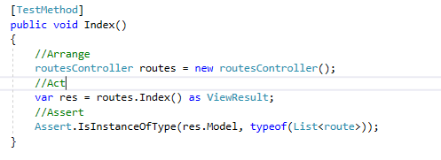

**Output:**

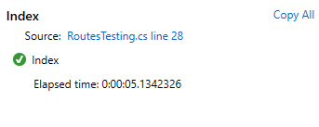

* **View Buses**

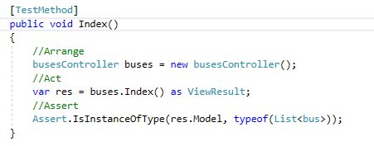

**Output:**

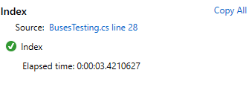

# **Chapter 6: Other Project Issues**

## **6.1 Project Limitation**

The limitation of the project are as follows:

* Not available as app for smartphones in Appstore (IOS) or Playstore (Android).
* Customer can’t cancel the booked ticket themselves. They have to communicate with company staff for this.
* There is no social media integration. User cannot connect their system account with social media account.

## **6.2 Future Works**

To make it more usable and efficient, new features and services must be added to the system. Here are some future works to be done in the near future are enlisted below:

* There is only one type of bus available in the system now. I am planning to add other different buses types as well.
* Whole Bus reservation service will be added in the near future.
* Social media integration will be added. After that, user will be able to login and sync with social media accounts.

## **6.3 Other project issues**

There were some issues while developing projects. They are:

* There was problem while writing LINQ query. It was overcome by doing more practices and guidance from teachers.
* There is problem in jquery of the system which creates problem in seat selection.
* There was issue with connection of database while testing. This issue was solved with after consult with the teacher.

## **6.4 Risk Management**

First of all, risk means a situation involving exposure to danger. It can also be defined as any threats to our business processes, system and data which causes loss if it is not managed properly. All projects involve risks and must be managed properly to enhance the probability of success of project. For this, risk management was developed.

Risk management is the process of identifying, assessing, prioritizing the risks and taking the required actions in order to eliminate the effects of the possible identified risks. This is done in order to minimize, monitor, and control the probability of unfortunate events. The following listed process are carried out in the risk management:

* Identify the risk
* Reduce the impact of risk
* Reduce the probability or likelihood of risk
* Risk monitoring

Various type of risk and measures to be taken to prevent these risks are listed below in the table.

To calculate the impact of each identified risk we use,

**Impact = Likelihood x Consequence**

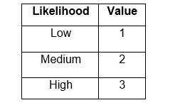

**Figure 7: Risk Likelihood and its value**

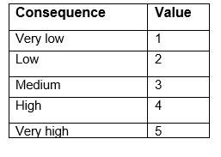

**Figure 8: Risk Consequences and its value**

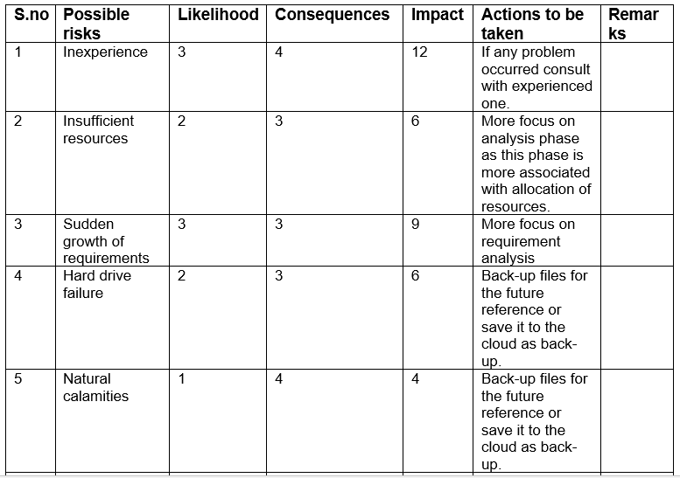

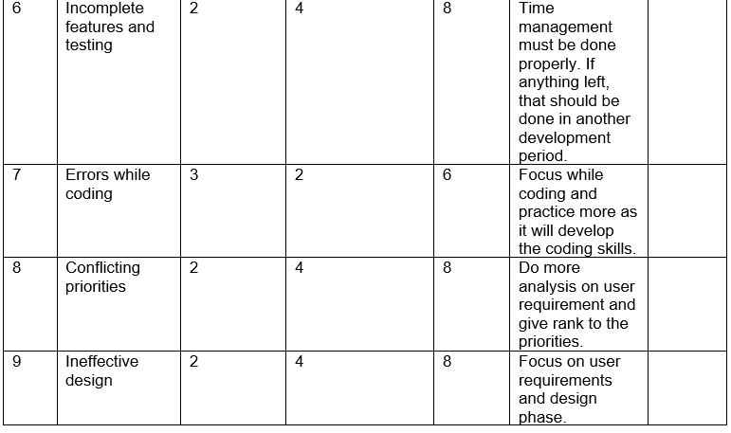

## **6.5 Configure Management**

First of all, configuration is the set of characteristics that define a final product or deliverable. This includes all functional and physical specifications. Configuration management is managing the configuration of all of the project’s key products and assets. This includes any end products that will be delivered to the customer, as well as all management products.

For the versioning of this project, I had used version controller tool that is GitHub. I had uploaded my proposal file in GitHub and the link is given below:

<https://github.com/stainer33/Computing-Project>

## **6.6 User Manual**

## **How to register?**

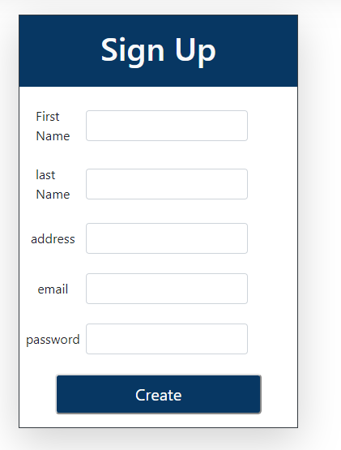

* Click the link “Create a account?”
* Fill up the signup form with valid values

* Click Create button

## 

## **How to login to the system?**

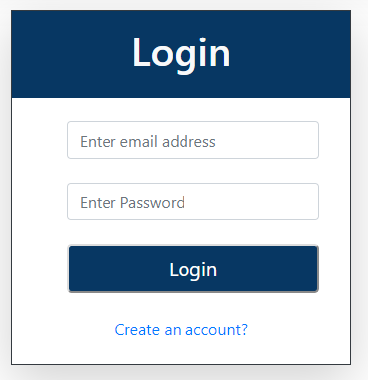

* Click “Login” at the top-right.
* Fill email and password for login.
* Click Login button

### **How to book a ticket?**

* Fill up the values in search box and click Search button

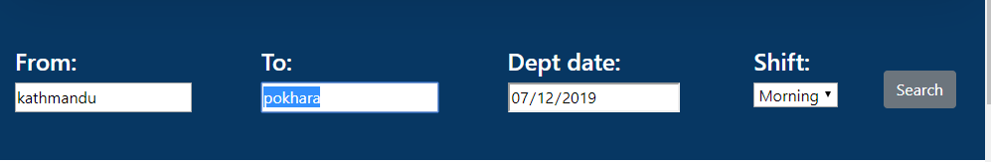

* To select the bus as desired/requirement, click View.

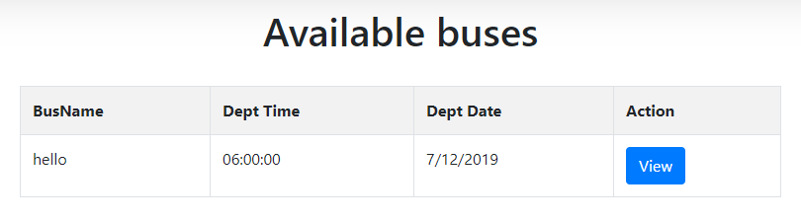

* Select the desired available seats and click Book button.

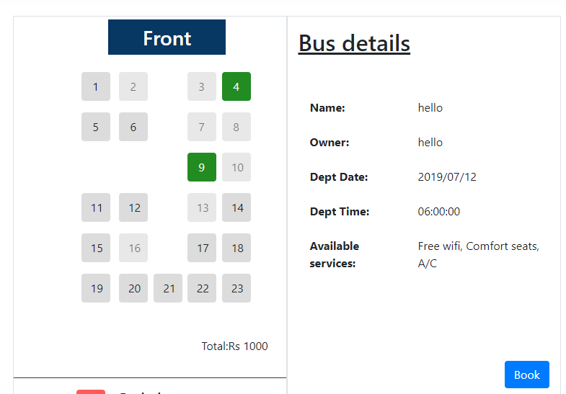

* At last, fill up the payment form and Click Create Button.

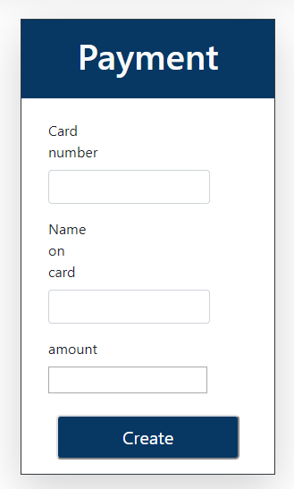

* Booking details will be shown after successful booking.

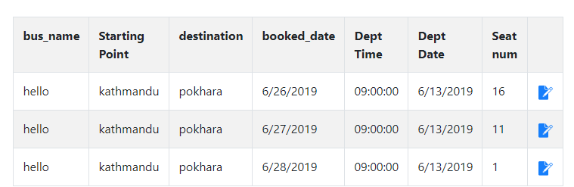

### 

### **How to change seat?**

* Click “View Booking” form menu on dashboard and then select the seat to change.
* Select seat to change and click Change button.

# **Conclusion**

The first thing done in this project is requirements gathering. Techniques like brain-storming, observation, document reviews, etc. were used for requirements gathering. Feasibility study regarding cost, time, and resources was performed after this. Object-oriented methodology is chosen for analysis phase of the project. The requirements were prioritized using MoScoW prioritization. Use-case diagram was developed to show user interactions with the system.

After completion of analysis phase, the project was proceeded towards design phase. In this phase, diagrams like class diagram, sequence diagram, activity diagram, ER diagram, etc. were developed to make physical design. Prototypes were also designed to facilitate the system design during implementation.

After taking the major decisions regarding the system during the design phase, it is developed as physical system in the implementation phase. Programming language, design pattern and framework for the project was chosen is this phase. Database and other tools were also chosen. Then, designing models were converted into real products.

After implementation, testing is done. It ensures the quality of the software and the functionalities developed are working as requirements. Black-box testing and unit testing were done in order to ensure it is working as expected. Test cases and test plans were formulated and specs were written to test the components.

During the project, many problems and issues were arisen. Overcoming them was the biggest challenge. Some of them were solved from self-learning and some of them were solved with the help of teachers and friends.